# Overview

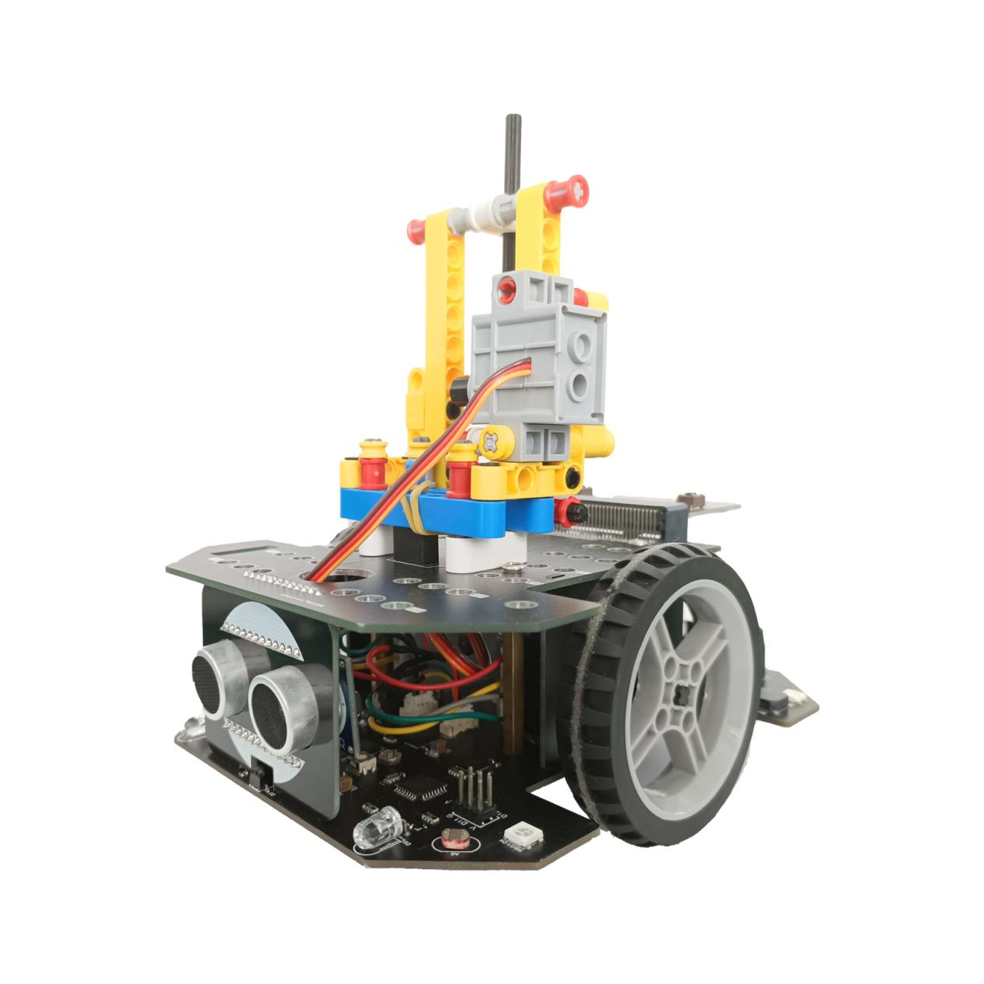

Cobit is a robot car designed for STEAM education, open-source maker and DIY lover. It is driven by a stepper motor and can walk at precise distances. It integrates ultrasonic module, photosensitive sensor, led and RGB lights, missed buzzer, infrared receiving sensor, infrared line tracking sensor, and can be connected with Bluetooth module and ESP-01 wifi module. Compatible with arduino, micro-bit, esp wifi, can use C, C++, JavaScript, Python, Blocks language for programming, there are Lego mounting holes and IO ports on the car body, it can be extended to a writing robot, and it is also very convenient to connect various types of modules.It is suitable for use from 7 + children to college students and electronic fans.

## Support

☛Quality Issues

☛Instructions for Use

☛Technical Exchange

☛Optimization Solution

☛Creativity Exchange

E-mail to✉：[cokoino@outlook.com](mailto:jex-spt@outlook.com)

This mail is working 24 hours during the working day. In order to better serve you, please clearly state the SKU of the product when you ask a question, and describe your problem in detail as much as possible.

## Colophon

Copyright © 2021 Cokoino Intelligent Technology Co., Ltd..

build-date: 2021-08-03

build-version: V1.0

Web: http://cokoino.com

## Legal Disclaimer Notice

Cobit has applied for related patents. Any individual or organization imitating or pirating related technologies, Cokoino has the right to pursue related legal liabilities.

The codes and circuits involved in this product are published on github: https://github.com/cokoino/CKK0008, you can use them in part or all of your own derivative works, as long as you also use the same license. The Cokoino brand and logo copyright belong to the Cokoino creative team and cannot be used for any commercial purposes without formal permission.

## **Table of Contents**

# **Tech specs**

Power source: Two lithium batteries.

Speed rating:

0 level: 0 revolutions per minute.

1 level: 15 revolutions per minute.

2 level: 30 revolutions per minute.

3 level: 60 revolutions per minute.

4 level: 120 revolutions per minute.

Wheel diameter: 65mm.

Walking precision: 0.51mm.

Precision of rotation angle: 0.9°.

Drive power: 110mN.m REF. per [stepper](D:/Youdao/Dict/8.9.6.0/resultui/html/index.html" \l "/javascript:;) motor.

Buzzer can be set frequency range: 20-- 1K Hz, volume: 0-5 level.

Maximum measurement distance of sonar is 255CM with an accuracy of +/-1CM.

Programming: Arduino, Micro:bit, ESP-01

distance between two wheels: 96mm

Length and width: 154\*118mm

# **Hareware**

## 3.1 Overview







## **3.2 Hardware block diagram**



## **3.3 Hardware Description**

**ATmega328P：Master Control Chip**

The core controller can update the code through the USB port.

|  |  |
| --- | --- |
| Flash Memory | 32 KB of which 0.5 KB used by bootloader |
| SRAM | 2 KB |
| EEPROM | 1 KB |
| Clock Speed | 16 MHz |
| Bootloader | Arduino UNO R3 |

**N76E003AT20：Companion Chip**

Burned the specific code, communicate with ATmega328P through I2C protocol, to drive DRV8833RTYR, Servo, Sonar and buzzer.

**CP2102：USB to serial chip**

Convert USB signal to TTL Serial level signal.

|  |  |
| --- | --- |
| Max Baud Rate | 921600 |
| USB protocol | USB Specification 2.0 compliant; full-speed (12 Mbps) |
| Driver Support | Windows 10/8/7/Vista/XP/Server 2003/2000 Windows CE |

**HR8833：Motor Driver Chip**

The double H-bridge motor driver can be used to drive 2 DC motors or 1 4-wire 2-phase stepper motor. It is controlled by the internal program of N76E003AT20. The I2C port of ATmega328P can send related commands to N76E003AT20 to control it.

|  |  |
| --- | --- |
| Power Voltage Range: | 2.7 V – 15 V |
| Output Current | 1.5-A RMS per H-Bridge |
| MOSFET On-Resistance: | HS + LS 400 mΩ |

**Motor port：**

To connect 4-wire 2-phase stepper motor divided into left and right, controlled by the HR8833 chip, please see the description for specific parameters as above.

**Infrared Receiving Sensor：**

The center frequency is 38K Hz, the receiving distance is 5-10 meters, the NEC infrared communication protocol is used by default, and the signal pin is connected to the D3 pin of ATmega328P.

**Passive Buzzer：**

It can produce sound up to 1K Hz , which is controlled by the internal program of N76E003AT20. The I2C port of ATmega328P can send related commands to N76E003AT20 to control it.

**Infrared Black and White Line Tracking Sensor：**

The black and white lines are sensed by the principle of infrared reflection. The signal pins are connected to the D9 and D10 pins of the ATmega328P. When the white line is encountered, the infrared is reflected, and the reflected signal can be obtained. The signal pin outputs low power. Level. When encountering a black line, infrared rays are absorbed, there is no reflected signal, and the signal pin outputs a high level. The sensitivity of the sensor can be adjusted through adj-R1 and adj-R2. It has been adjusted at the factory, and it is not recommended to adjust it again if it is not necessary.

**Photoresistor Sensor：**

Read the intensity of the light, divided in left and right, output the analog value, the signal pins are connected to the A6 and A7 pins of the ATmega328P respectively. The stronger the light, the smaller the resistance value of the photoresistor, and the greater the voltage value output by the internal circuit.

**RGB LED：**

WS2812 RGB light can emit controllable red, green and blue base colors. There are 4 lights in total. The serial numbers are divided into RGB1-RGB4. Various colors of light can be formed by controlling the intensity of the three primary colors. The signal input pin is connected to the ATmega328P. D4 pin.

**Head light：**

The 5mm white LED are divided in left and right, respectively controlled by the D5 and D6 pins of ATmega328P. The PWM signals of the D5 and D6 pins can make the LED emit white light of different intensities.

**Type C USB Port：**

USB communication port, through which the code and data on the PC can be sent to cobit, and it can also be used to update the program of ATmega328P.

**Power Switch：**

To control the power on and off of the battery box, the battery box circuit has a 5A fuse and an anti-connection diode for safety.

**Voltmeter：**

It is used to detect the voltage of the battery box and output the analog value. The signal pin is connected to the A3 pin of ATmega328P. Because the voltage obtained by A3 is the battery voltage divided by 1/10, the value obtained by A3 must be multiplied by 10 to be the real battery voltage.

**KEY-D2 Button：**

The signal pin is connected to the D2 pin of ATmega328P. Press the button to output low level, otherwise output high level.

**RESET Button：**

This signal pin is connected to the reset pin of ATmega328P, which triggers ATmega328P reset when the button is pressed.

**Ultrasonic Port：**

V=5V, G=GND, used for external HC-SR04 sonar module, controlled by the internal program of N76E003AT20, ATmega328P I2C port sends related commands to N76E003AT20 to read HC-SR04 data. When the HC-SR04 sonar module is connected, the maximum test distance is 255CM, and the accuracy is +/-1CM.

**Servo Port：**

V=5V, G=GND, S=Servo control signal, used to connect 3 channels of servos, controlled by the internal program of N76E003AT20, ATmega328P I2C port can send related commands to N76E003AT20 to control the external servos.

**Bluetooth Port：**

For external Bluetooth module, V=5V, G=GND, the signal pin is directly connected to the D8 (connected to the TX pin of the Bluetooth module) and D7 (connected to the RX pin of the Bluetooth module) pins of ATmega328P.

**ICSP Port：**

V=5V, G=GND, mainly used to burn the bootloader of ATmega328P.

**ESP-01 wifi Port：**

Used to connect ESP-01 wifi module, TX and RX signal pins are connected to D12 (corresponding to the TX pin of esp-01) and D13 (corresponding to the RX pin of esp-01) of ATmega328P through a 3V-5V level conversion circuit.

**Micro:bit Port：**

Used for external Micro:bit motherboard, P0 and P1 signal pins are connected to ATmega328P's D8 (corresponding to Micro:bit's P0 pin) and D7 (corresponding to Micro:bit's P1 pin) through a 3V-5V level conversion circuit .

**Digital Port：D11, D12, D13**

These are the digital IO port of ATmega328P, among which D11 can output PWM signal.

**Analog Port：A0, A1, A2**

It is the analog port of ATmega328P, which can read analog values and can also be used as a digital port.

**Power Output Port：G, 5V**

GND = G, power supply = 5V, maximum output power is 10W, which can be used to power peripherals.

**I2C Port：SCL, SDA**

It is the I2C communication interface of ATmega328P, SDA=A4, SCL=A5, it can communicate with other I2C devices.

## **3.4 Further information**

I2C Protocol：

<https://www.nxp.com/docs/en/user-guide/UM10204.pdf>

NEC Infrared Transmission Protocol：

<https://techdocs.altium.com/display/FPGA/NEC+Infrared+Transmission+Protocol>

# **Detailed [list](D:/Youdao/Dict/8.9.6.0/resultui/html/index.html" \l "/javascript:;)**

|  |
| --- |
| **Basic Parts**  6(2) |
| **Lego Parts**  IMG_4490 |

# **Install the cobit**

# BitApp

We have developed a Bluetooth APP (BitApp) for Android phones for Cobit, which is compatible with the Bluetooth module we provided and the integrated Bluetooth on the micro:bit V1/2 motherboard. This is very convenient to control Cobit with mobile phone. The explanation and installation in this chapter are preserved for the subsequent Bluetooth control examples.

## **6.1 Installation**

The installation package is stored in the "APK" folder. Please copy the installation package to your phone and install it. If there is a risk prompt during the installation process, please continue to install it. This is because the security monitoring of the mobile phone judges the App as an unknown application. The application software itself does not carry any viruses or poses security risks. Please feel free to use it.

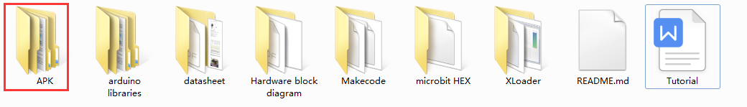

After the installation is complete, you need to turn on the Bluetooth of your mobile phone to use it normally, as shown in the figure below:

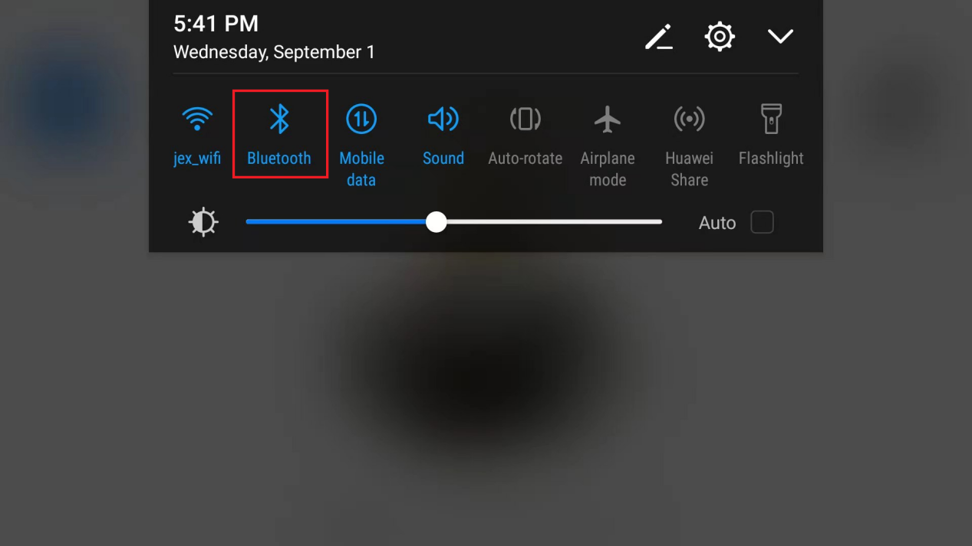

Then please click APP Icon , Open App as below：

|  |
| --- |
| 641125623e99e17dd7c336e6edd4349 |

## **6.2 Interface**

|  |
| --- |
| 图片1 |

**1：Floating Down Menus**

Contains two pages, one is the Bluetooth page and the other is the App information page.

**2：Bluetooth Page**

This page includes Bluetooth search, selection, and pairing. When the Bluetooth of the mobile phone is turned on, when entering this page, the App will automatically search for the Bluetooth nearby and display their name, UUID and RSSI. This App is only compatible with the Bluetooth and HM-10 Bluetooth on the Micro:bit V1/2 motherboard. There are two ways to connect them.

**Auto Connect：**Move the phone close to the Bluetooth that needs to be connected, and then click the Bluetooth page. The App will automatically search for Bluetooth and judge the distance between the phone and the connected Bluetooth based on the RSSI signal strength. When the distance is less than or equal to the preset strength, it will automatically connect the Bluetooth.

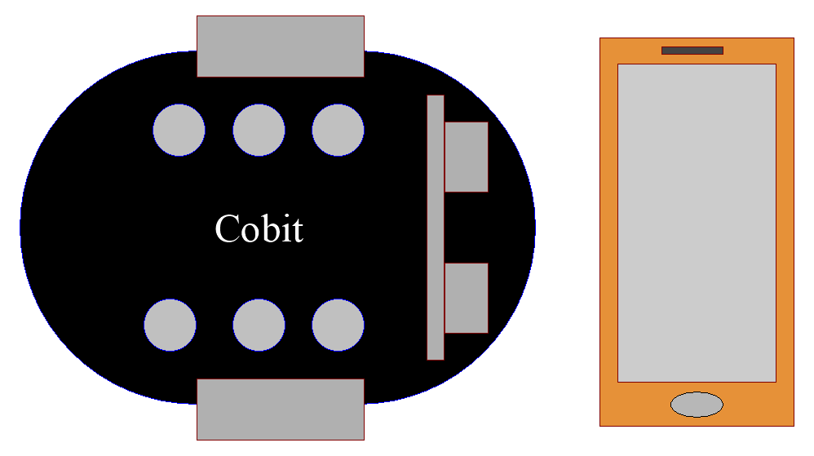

**Manually Connect：**Click the Bluetooth page from a long distance, the App will automatically search for Bluetooth, and then click the name of the Bluetooth you need to connect, and the App will connect to this Bluetooth.

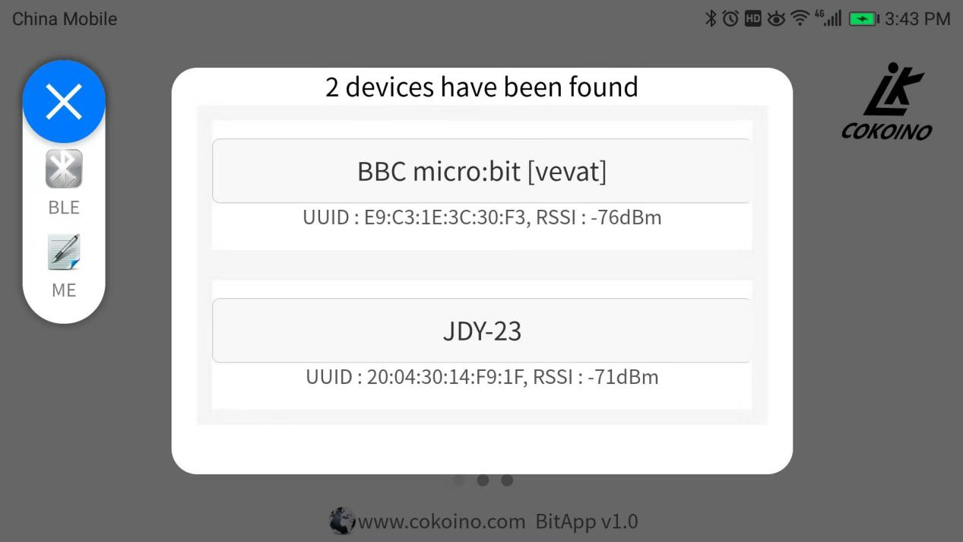

A successful pairing does not necessarily mean that the phone and Bluetooth can communicate normally. It must pop up "Bluetooth ok" after the connection is successful to truly communicate with Bluetooth, as shown in the figure below:

|  |
| --- |
| 微信图片_20210906195447 |

**3：App Information Page**

This page contains the internal information of the App, such as the design team, company, data communication format, version number, and update records.

|  |
| --- |
| 微信图片_20210906194938 |

**4：Application Selection Menu**

This App can be applied to multiple products. You can select different products by sliding this menu left and right, and then click the product you want to operate to enter the operation page. Here is an example with Cobit.

**Operation Page A:**

|  |
| --- |
| 图片2 |

1：Back button

2：Up button, button value：S-0x00-0x01-P

3：Left button, button value：S-0x00-0x02-P

4：Right button, button value：S-0x00-0x04-P

5：Down button, button value：S-0x00-0x05-P

6：Middle button, button value：S-0x00-0x03-P

7：+ button, button value：S-0x00-0x06-P

8：- button, button value：S-0x00-0x07-P

9：Light button, button value：S-0x00-0x08-P

10: Speaker button, button value：S-0x00-0x09-P

11：Sonar button, button value：S-0x00-0x0a-P

12：Switch button, button value：S-0x00-0x0b-P

13：Line tracking button, button value：S-0x00-0x0c-P

14：Following button, button value：S-0x00-0x0d-P

15：Switch button, button value：S-0x00-0x0e-P

16：Acceleration button, button value：S-0x14-dataX-dataY-dataZ-P

17：Slider button, button value：S-0x0a-data-P

18：Function button

19：Color button

20：Music button

**Operation Page B：**

|  |
| --- |
| 图片3 |

1：Color Red button, button value：S-0x00-0x0f-P

2：Color Green button, button value：S-0x00-0x10-P

3：Color Blue button, button value：S-0x00-0x11-P

4：Color Purple button, button value：S-0x00-0x12-P

5：Toggle button, button value：S-0x00-0x13-P

6：Color Sea Green button, button value：S-0x00-0x14-P

7：Color Yellow button, button value：S-0x00-0x15-P

8：Color Grey button, button value：S-0x00-0x16-P

9：Color Dark Purple button, button value：S-0x00-0x17-P

**Operation Page C：**

|  |
| --- |
| 66f2e7727847eb28fe1e57663a6f238 |

1：do button，button value：S-0x00-0x18-P

2：re button，button value：S-0x00-0x19-P

1：mi button，button value：S-0x00-0x1a-P

3：fa button，button value：S-0x00-0x1b-P

4：sol button，button value：S-0x00-0x1c-P

5：la button，button value：S-0x00-0x1d-P

6：ti button，button value：S-0x00-0x1e-P

# **7.Geting start with Cobit for arduino**

Arduino is an open-source electronics platform based on easy-to-use hardware and software. You

can use the Arduino programming language (based on Wiring), and the Arduino Software (IDE),

based on Processing.

Official link：<https://www.arduino.cc/>

## **7.1 Arduino Development Board**



Arduino is an open source platform. Whose many open source development boards are officially developed for electronic fans. The most famous one is Arduino UNO R3, which is a main board based on the ATmega328P control chip. Cobit's ATmega328P chip is also based on its Bootloader.

Arduino development board link：

<https://www.arduino.cc/en/Main/Products>

## **7.2 Arduino IDE**

The open sourced Arduino software (IDE) makes it easy to write code and upload code. It reserves with a wealth of API interfaces with C and C++ programming languages, to meet various development needs for projects.

**Install arduino IDE**

Enter arduino web [https://www.arduino.cc/,](https://www.arduino.cc/%EF%BC%8C) Click  .  


Choose the installation package suitable for your PC system, here we take the windows system as an example.  
  
ClickEnter into the installation package download interface.



ClickStart to download the arduino installation package. After the installation package is downloaded, please unzip the installation package to install it.

More installation details and installation methods of different PC systems can also be referred to：<https://www.arduino.cc/en/Guide>





**Arduino IDE Menu**

：Verify Checks your code for errors compiling it.

：Upload Compiles your code and uploads it to the configured board. See [uploading](https://www.arduino.cc/en/Guide/Environment" \l "uploading) below for details.

Note: If you are using an external programmer with your board, you can hold down the "shift" key on your computer when using this icon. The text will change to "Upload using Programmer".

：New Creates a new sketch.

：Open Presents a menu of all the sketches in your sketchbook. Clicking one will open it within the current window overwriting its content.

Note: due to a bug in Java, this menu doesn't scroll; if you need to open a sketch late in the list, use the File | Sketchbook menu instead.

：Save Saves your sketch.

：Serial Monitor Opens the [serial monitor](https://www.arduino.cc/en/Guide/Environment" \l "serialmonitor).

For more IDE usage details, please refer to：<https://www.arduino.cc/en/Guide/Environment>

## **7.3 Arduino Programming Language**

Arduino has a set of programming syntax and API interface based on C and C++, which can realize various functions. The Arduino programming language can be divided into three main parts: function, value (variable and constant) and structure.

For specific learning materials, please refer to：<https://www.arduino.cc/reference/en/>



## **7.4 Install the USB-to-UART COM Port Driver**

There is a Type-C USB port on the Cobit, and it integrates a CP2102 USB-to-serial chip. It can communicate with the serial port of ATmega328P. The CP2102 driver must be installed on the PC before use.

The IDE of Arduino version 1.8 or higher has included the CP201X driver inside. When connecting to the USB port of the PC, the PC will automatically recognize and install the driver.

If the driver installation fails or you want to manually update the driver, select the "This PC" menu on the PC desktop, then right-click and select "Properties"--->"Device Manager".  


This device manager page has a device with a yellow exclamation mark, as shown above. Select this device, click the right mouse button, and select "Update driver".  


Click“browse my computer for updated driver software”。  


There is a DRIVERS folder in Arduino software installed package（）, open driver folder and you can see the driver of CP210X series chips.

We click “Browse”, then find out the driver folder, or you could enter “driver” to search in rectangular box, then click “next”, the driver will be installed successfully.

  
  
Open device manager, we will find the yellow exclamation mark disappear. The driver of CP2102 is installed successfully.  
  


The driver can also be downloaded from the original official website:：

<https://www.silabs.com/developers/usb-to-uart-bridge-vcp-drivers#software>



## **7.5 Cobit Apply with Arduino Platform**

Cobit uses an ATMEGA328P as the core processor and burns the Arduino UNO R3 boot program at the factory. Therefore, it is fully compatible with Arduino UNO R3. When used on the arduino platform, it can be set in accordance with the UNO R3 parameters.



## **7.6 Arduino library for Cobit**

We use the arduino platform to develop a library file for Cobit. This library contains all the functions of Cobit, making it easier and more efficient for Cobit to use arduino programming. To use this library, you need to add the files in the "arduino libraries" folder we provide "Cobit" folder to the "libraries" folder under the Arduino installation directory, as shown below;

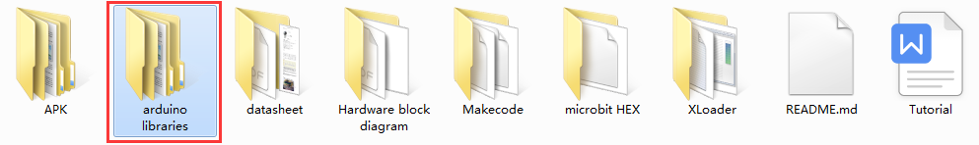



Note: This library is based on UNO R3 development board.

Cobit is also stored in：<https://github.com/Cokoino/CKK0008> this arduino libraries folder.



**Cobit's arduino example**

All our functions are integrated in the arduino library. In the previous step, we have decompressed the library file to the "libraries" folder of the arduino IDE. Now we can find all the sample codes of cobit in the arduino IDE example, as follows picture:

Note: After decompressing the Cobit library file to the "libraries" folder under the Arduino installation directory, you need to close the IDE and restart to find the Cobit example in the IDE example.

A simple example here:

Choose code：



Select board:



Select port:

Use the Type C USB cable to connect the Cobit to the PC (open the device manager of the PC, if the device displays an exclamation mark, please refer to the "Install the USB-to-UART COM port driver" chapter to install the driver).



Select the corresponding port in the arduino IDE according to the port of the device manager.



Check the code (if there is an error in the code, this step cannot be passed, and an orange error message is printed in the information window at the bottom of the IDE).

Upload code:



Code effect:

The two headlights of the Cobit are on for 1 second and then off; then the breathing light is on, and then the breathing light is off; Keeping like this .

**New Cobit Project:**

If you want to use Cobit for implement of custom functions, you only need to create a new project, include the necessary head files in the code, and then use the API interface reserved by the sample or refer to the analysis of the library file to select the required functions, and then save, as follows picture.

Create New Cobit Project:



Add head files:



Check the function usage method of the library file:



Reminder: It is recommended to use "Notepad++" software to view the above documents, download URL:

<https://notepad-plus-plus.org/downloads/>

## **7.7 Example Tutorial**

Cobit's sample courses have been integrated in the cobit library, because it is very convenient and avoids errors caused by copying. Please carefully check the comments after the "//" in the code when using the example, it will be very helpful for you to understand the function of the code.

### 1\_Examples of headlights



Cobit Integrats two white 5MM headlights, the "Headlight" example provides control of their on and off states. You can also control their brightness, this function can achieve the effect of breathing light.

The brightness of the light is controlled by a PWM signal. PWM means pulse width modulation, that is, pulses with variable high and low time widths are periodically generated. When the high level is high, the headlights will be on, and when the low level is low, the headlights will be off. For example, the period of a pulse is 255 milliseconds (period = high level time + low level time), when the high level time width is 255 milliseconds , The low-level time width is 0, and the headlights are the brightest at this time; when the high-level time width is 0 and the low-level time width is 255 milliseconds, the headlights are the darkest at this time. After uploading the code, the two headlights of Cobit will light up for 1 second and then turn off; then the breathing light will turn on, and then the breathing light will turn off; and keeps working like this.

### 2\_Buzzer Example





Cobit has a passive buzzer. When the passive buzzer has been supplied with direct current, the buzzer will not make sound, and some will cause the buzzer to become hot. In severe cases, the buzzer will be damaged. Give the passive buzzer a signal source with frequency to produce a sound. The "Buzzer" example provides the control of the passive buzzer on and off, and can also adjust its volume and sound frequency (20---1000 Hz).

After uploading the code, the buzzer will emit a sound of 20---1000 Hz, and keeps working like this.

### 3\_Examples of Photoresistors





The Cobit front end integrates two photoresistors, and the "PR" example can read their analog values.

Photoresistor is a component that converts light signals into electrical signals. The stronger the luminosity, the smaller the resistance of the photoresistor. After uploading the code, open the serial monitor of the arduino IDE, set the baud rate to 9600, and the monitor will print the data of the two photoresistors.

### 4\_RGB light example





Cobit has 4 RGB lights, which can emit red, green, and blue lights. By controlling the brightness of the three lights, and then combining with each other can produce light of various colors.

After uploading the code, 4 RGB lights will turn on (white light), and then turn off.

### 5\_Infrared receiver example



There is an infrared receiving sensor on the front and rear of the Cobit. This design makes the dead angle of the Cobit smaller when receiving data, and the received data is more accurate and more sensitive.

After uploading the code, open the serial monitor, set the baud rate to 9600, and then use the infrared remote control provided by us or the remote control compatible with NEC protocol to send key data to the Cobit, and the serial monitor will print the key value of the remote control.

Infrared Remote Control Key Value:



### 6\_Example of Infrared Black and White Line Detection



Two infrared pair tube line tracking sensors are integrated at the bottom of the Cobit, and the initial default output is high level. The infrared pair tube is divided into two parts, one is the infrared transmitting end, the other is the infrared receiving end, the infrared transmitting end transmits infrared signals, and the receiving end receives the infrared signals reflected back after hitting an object.

The black line has a good absorption effect on infrared rays. When the infrared rays are emitted from the transmitting end of the tube patrol sensor to irradiate the black line, the infrared rays are absorbed without forming a reflected signal, and the receiving end does not receive a signal, and the line patrol sensor outputs a high level (1); When the white line is irradiated, because the white line has no absorbing effect on infrared rays, the infrared signal is reflected back, the receiving end receives the signal, and the line-following sensor outputs low level (0).

After uploading the code, open the serial monitor, set the baud rate to 9600, turn the Cobit over, use white paper to approach the two infrared sensors, if the left infrared sensor detects the serial monitor and print "left detected", if the left The infrared sensor detects the serial monitor printing "right detected", if the left and right infrared sensors both detect the serial monitor printing "left detected" and "right detected".

### 7\_Sonar Example





Ultrasonic is a mechanical wave with an extremely short wavelength. The wavelength in the air is generally shorter than 2 cm (centimeters). It must rely on the medium to propagate and cannot exist in a vacuum (such as space). But because of its short wavelength, it is easily lost and scattered in the air. It is not as far as audible sound and infrasound waves. However, the short wavelength is easier to obtain anisotropic sound energy, which can be used for cleaning, ranging, etc.

A sonar interface is reserved on the Cobit, which can be connected to the HC-RS04 ultrasonic module for distance measurement. Cobit is equipped with the HC-RS04 ultrasonic module by default, and integrates the module's API in the Cobit library. The measurement data of the module can be read by using the API, which greatly reduces the difficulty of use. The maximum measuring distance is 255cm, and the accuracy is +/-1CM.



After uploading the code, open the serial monitor, set the baud rate to 9600, place an obstacle in front of the cobit, and the serial port will print out the distance between the cobit and the obstacle. The data unit is cm.

### 8\_Servo Example



There are 3 servo drive ports reserved on the Cobit, which can be connected with Lego or SG90 servos. Cobit is equipped with a Lego servo by default, and integrates the API of the module into the Cobit library. The API can be used to drive the servo simply and quickly, which is easier to use.

After uploading the code, connect the servo to any servo interface, and the servo will swing back and forth between 0---180 degrees.

About Servo:

①Power negative (black), power positive (red), signal (yellow);

②Potentiometer: can measure the position of the output shaft, which belongs to the feedback part of the entire servo mechanism;

③Internal controller: processing signals from external control, driving motors and processing feedback position signals are the core of the entire servo mechanism;

④Motor: as an actuator, how much speed, torque, and position are output by it;

⑤Transmission mechanism / servo system: This mechanism scales the stroke of the motor output to the angle of the final output according to a certain transmission ratio



The output of the servo is controlled by sending a PWM signal to the signal line of the servo. The period and duty ratio of the PWM are controllable, so the duty ratio of the PWM pulse directly determines the position of the output shaft.

Here is an example:

When the pulse width is 1ms, the output shaft of the servo will move to the smallest position (0 degrees);

When the pulse width is 1.5ms, the output shaft of the servo will move to the middle position (90 degrees);

When the pulse width is 2ms, the output shaft of the servo will move to the smallest position (180degrees).

### 9\_Voltmeter example



A voltmeter is designed on Cobit to read the voltage of the battery. The API in the Cobit library can be used to quickly read the battery voltage and voltage percentage. The voltage percentage is a mapping value:

|  |  |
| --- | --- |
| Range of Voltage | Mapped Voltage Percentage |
| 6.5V---8.4V | 0---100% |

After uploading the code, put two 18650 lithium batteries into the battery box of the Cobit, turn the power switch to the "ON" state, turn on the serial port monitor, set the baud rate to 9600, and the serial port will set the voltage of the two lithium batteries in series The value and voltage percentage are printed out.

### 10\_Wheels Example



There is a wheel with a diameter of 65mm on the left and right sides of the Cobit. Two stepper motors are used as the power of the wheel. The rotation angle and the rotation arc of the wheel can be controlled. The rotation angle accuracy is +/-0.9 degrees, and the rotation speed is divided into 0-- -4 gears (0 = 0rpm, 1 = 15rpm, 2 = 30rpm, 3 = 60rpm, 4 = 120rpm).

We have compiled the complex stepper motor drive code into a library file, and reserve a wealth of AIP interfaces. Using AIP interfaces can implement various applications very simply and efficiently. For detailed usage, please refer to the "Wheels" sample code." //" The analysis behind.

After uploading the code, the two motors on the left and right of Cobit first rotate 360 ​​degrees clockwise, and then rotate counterclockwise for 3 seconds, and then continue like this.

### 11\_Basic operation of Cobit



This example includes the basic driving operations of Cobit, such as the steering, driving direction of the car and their corresponding delay functions.

After uploading the code, Cobit will turn 360 degrees, turn right 360 degrees, drive 200mm forward, and then reverse 200mm; then turn left continuously for 2 seconds, turn right continuously for 2 seconds, and drive forward for 1 second, then Go back for 1 second, and then keeps like this.

### 12\_Infrared remote control car





Cobit is equipped with an infrared remote control by default, and each button has a different key value. We give each key value a different function, and then send the key value to Cobit through the remote control, and Cobit obtains the key value and then implements the key Value function.

Arduino Key value and function:

|  |  |  |  |  |  |  |  |  |  |
| --- | --- | --- | --- | --- | --- | --- | --- | --- | --- |
| Key | 0 | 1 | 2 | 3 | 4 | 5 | 6 | 7 | 8 |
| Key Value | FF9867 | FFA25D | FF629D | FFE21D | FF22DD | FF02FD | FFC23D | FFE01F | FFA857 |
| Function | null | Turn on the buzzer | Turn off the buzzer | Turn on the RGB LED | Turn off the RGB LED | Turn on the Car light | Turn off the Car light | null | null |
| Key | 9 | \* | # | ▲ | ▼ | ◀ | ▶ | OK |  |
| Key Value | FF906F | FF6897 | FFB04F | FF18E7 | FF4AB5 | FF10EF | FF5AA5 | FF38C7 |  |
| Function | null | null | null | forward | back | turn left | turn right | stop |  |

### 13\_Line Detection Car





The car is with function of the infrared line Detection. Use 2 cm wide black paper cloth on the white black paper to form a line of track shape. Black objects have the effect of absorbing infrared rays, and white objects have the effect of reflecting infrared rays. Use this function You can keep the car walk along the black line.



is“0”，is“1”

### 14\_Line Detection Restricting



Line Detection Restricting function realized by infrared line Detection sensor. After burning the code, stick a square with black tape on the white paper, and put the car into the square. When the car is driving in the square, the two infrared line patrol sensors keep receiving the reflected signal, it means that the car is still on the desktop. When the car hits the black line, the line-following sensor does not form a reflection signal, and the car immediately brakes to stop, and then turns direction to travel.

### 15\_PR Car



A photoresistor sensor is integrated on the left and right sides of the Cobit, which can be used to determine the brightness of the light on both sides of the Cobit, and then the motor rotates to make the light brightness obtained by the photoresistor sensors on both sides of the Cobit basically the same, so that the Cobit always keeps facing the light source. Follow the light source.

Note: In order to avoid the influence of other light, please carry out this experiment in a dark place.

### 16\_Sonar Car



We provide the Sonar module for the Cobit car by default. As long as the module is inserted into the sonar interface of the Cobit, the Cobit has the function of measuring distance.



The function of this code is to use the ultrasonic sensor on the front end of the Cobit to measure the distance of the obstacle in front. If the distance is less than the distance set by the program, the car will stop immediately, and then turn to measure the distance of the obstacles on the left and right sides, and select the farthest distance and greater than the minimum distance If the left and right distances are less than the minimum distance, the car will make a U-turn.

### 17\_Drawing Car



This function of the Cobit is completed in conjunction with Lego accessories. There are standard Lego mounting holes reserved on the car body. As long as the pen holder structure is built according to the assembly instructions, the Cobit can paint then.



Burn the code into the Cobit and place the Cobit on the upper left corner of the A4 paper. The cart will draw a rectangle on the paper. If you need more shapes, you can refer to the code programming.

### 18\_Writing Car



This example is completed with Lego accessories. The car body has standard Lego mounting holes. You need to build the Lego pen holder structure according to the assembly instructions to enable the Cobit to have the writing function.

Burn the code into the Cobit, stitch together 3 sheets of A4 paper, put the Cobit on the upper left corner of the first A4 paper, the car will write "123ABCabc" on the paper, you can also fill in the sample code string you need.



### 19\_Bluetooth Port Example



A Bluetooth port is reserved on Cobit. This port is a Soft serial port with a fixed baud rate of 115200. The connection method with the Bluetooth module is as follows:

|  |  |  |  |  |
| --- | --- | --- | --- | --- |
| Bluetooth port | V（5V） | G | D8 | D7 |
| Bluetooth module | VCC | GND | TX | RX |

After uploading the code, connect the Bluetooth to the port, then use the Bluetooth APP of the mobile phone to pair the Bluetooth, open the serial monitor, set the baud rate to 9600, press any button on the Bluetooth APP, the serial monitor of the Arduino IDE will print the buttons value of the Bluetooth APP.

Note: Bluetooth must be in serial port transparent transmission mode to transmit data to Cobit, and the module defaults to transparent transmission mode.

### 20\_Bluetooth Car



A Bluetooth port is reserved on Cobit. It is a Soft serial port with a fixed baud rate of 115200. The connection method with the Bluetooth module is as follows:

|  |  |  |  |  |
| --- | --- | --- | --- | --- |
| Bluetooth port | V（5V） | G | D8 | D7 |
| Bluetooth module | VCC | GND | TX | RX |

We have developed an APP for Android phones. Each button has a different button value. We give each button a different function, and then send the button value to Cobit through the phone, and Cobit obtains the button value before implementing the button value function.

Button value and function:：

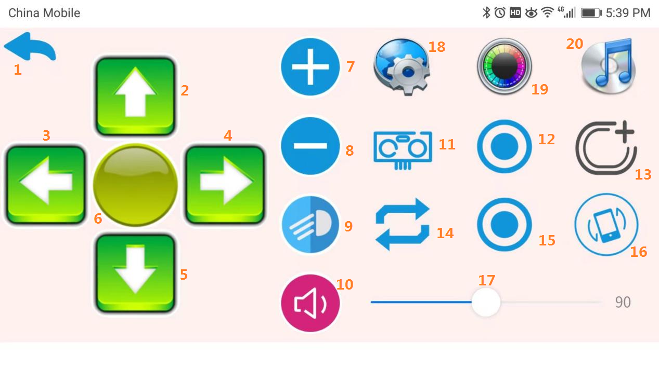

|  |  |  |  |  |  |
| --- | --- | --- | --- | --- | --- |
| SN | 1 | 2 | 3 | 4 | 5 |
| Function | back | forward | turn left | turn right | return |
| SN | 6 | 7 | 8 | 9 | 10 |
| Function | stop | reserved for use | Reserved for use | on/off head light | speaker |
| SN | 11 | 12 | 13 | 14 | 15 |
| Function | on/off sonar car | reserved for use | reserved for use | reserved for use | reserved for use |
| SN | 16 | 17 | 18 | 19 | 20 |
| Function | on/off  acceleration car | headlight brightness | switch button | switch button | switch button |

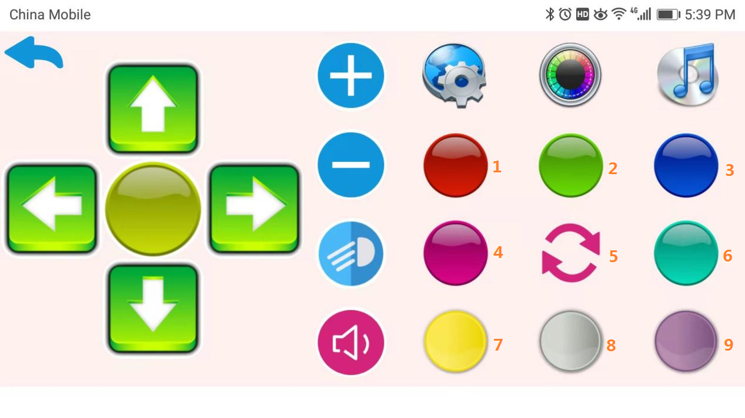

RGB color control

|  |  |  |  |
| --- | --- | --- | --- |
| SN | 1 | 2 | 3 |
| Function | Red | Green | Blue |
| SN | 4 | 5 | 6 |
| Function | Purple | Close all RGB lights | Sea Green |
| SN | 7 | 8 | 9 |
| Function | Yellow | Grey | Dark purple |

# **8.Geting start with cobit for micro:bit**

The Micro:bit Educational Foundation is a not-for-profit organisation founded in the UK in 2016, with the aim of inspiring every child to create their best digital future.

They do this by:

developing hardware and software that inspires young people to get excited about technology and the opportunities it presents for them

creating free, user-friendly educational resources to support teachers in delivering engaging and creative lessons

working with like-minded partners to deliver high-impact educational programmes across the globe.

Micro:bit official website：<https://microbit.org/>

## **8.1 Micro:bit Development Board**

Micro:bit has its own dedicated development board, which is divided into two versions, V1 and V2. The main version now uses V2. It has powerful functions and integrates most commonly used sensors. It retains an externally expanded IO port for external Expand the experiment.





More details see here：<https://tech.microbit.org/>

<https://microbit.org/get-started/user-guide/overview/>

## **8.2 Micro:bit Editor and Programming Language**

**Editor selection：**

You can program your micro:bit in the online MakeCode block or Python text editors. Our **[Let's code](https://microbit.org/code/)** page helps you choose the one that's right for you.

Let’s code page: <https://microbit.org/code/>



**Grammar Tutorial:**

The Micro:bit platform provides official API and device usage references, including detailed usage methods of makecode, python, and JavaScript.

APIs: <https://makecode.microbit.org/reference>



Device: <https://makecode.microbit.org/device>

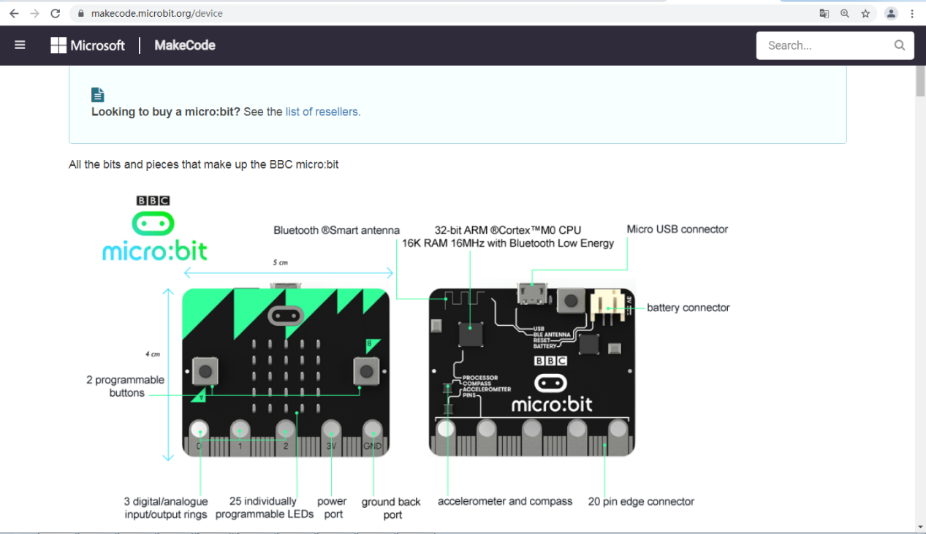

Logic and data type reference.

[Blocks language](https://makecode.microbit.org/blocks): <https://makecode.microbit.org/blocks>



[JavaScript language](https://makecode.microbit.org/javascript): <https://makecode.microbit.org/javascript>



## **8.3 Get started micro:bit**

The best way to learn is to do it. Start with imitation and follow the learning files to do it again. The official website of Micro:bit provides a wealth of video tutorials. We will follow the video to operate it again and be familiar with the basic functions of Micro:bit development. Please be sure to carefully review the video tutorials linked below.

Video tutorial link:<https://www.microbit.org/get-started/first-steps/introduction/>

More video tutorials can also refer to the link：<https://makecode.microbit.org/>



## **8.4 Cobit Uses Micro:bit for Programming**

We use makecode to develop a dedicated expansion package for Cobit, so that we can also use micro:bit to program Cobit, the use of this micro:bit expansion package is based on the Cobit burned arduino "microbit" code, otherwise micro:bit extension package does not work.

### 8.41 Burn Arduino Microbit Code

There are two ways to burn the Arduino microbit code, choose one of the two. XLoader burning does not need to set up a programming environment. Just make sure to install the USB driver. If the USB driver is not installed, please refer to the "Install the USB-to-UART COM port driver" chapter of the Arduino section; Arduino IDE burning is a bit more complicated and needs to be installed. Arduino IDE and cobit library files, and USB driver must be installed.

**XLoader Burning**



The burning application and the HEX file to be burned are stored in the downloaded folder "XLoader" and "microbit HEX", Open ”XLoader”folder, double click””this icon to start the APP, select ”Microbit.hex”, and select device ”Uno (ATmega328)”, select COM port, and set the baud rate to 115200, click "Upload" to burn the code.

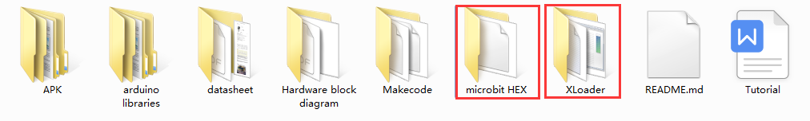

**Arduino IDE Burning**

Download the arduino "microbit" code. For the specific arduino IDE download method, Cobit library installation and USB driver installation method, please refer to the "Getting start with Cobit for arduino" chapter. The "microbit" code burning steps are as follows.

Select Code:



Select Board:



Select Port:

Use the Type C USB cable to connect the Cobit to the PC, and open the device manager of the PC (if the device displays an exclamation mark, please refer to the "Install the USB-to-UART COM port driver" chapter of the Arduino chapter to install the driver).



Select the corresponding port in the arduino IDE according to the port of the device manager.



Check the code (if there is an error in the code, this step cannot be passed, and an orange error message is printed in the information window at the bottom of the IDE).



Upload the Code:



### 8.42 Add Micro:bit's Cobit Expansion Package

Micro:bit's Cobit extension package needs to be loaded before use. The steps are as follows:





Link of Cobit expansion package based on micro:bit:<https://github.com/Cokoino/pxt-cobit>



Now all preparations are complete, and you can use makecode to program Cobit.

### 8.43 Refresh Micro:bit's Cobit extension package

Micro:bit extension packages are all saved on the github website, and the modified information on the github website will have a version record on the website. For example, the expansion package V1 is added for the first time, and the project is created using the expansion package V1. After a period of time, we may optimize the expansion package and update the expansion package information on the github website. At this time, the github website will automatically The version of the expansion pack is upgraded to V2. If we use the makecode online programming webpage to import the previous project, we still use the V1 version of the expansion pack. If we want to use the latest expansion pack, we need to refresh the expansion pack manually at this time.

Import the previous project:

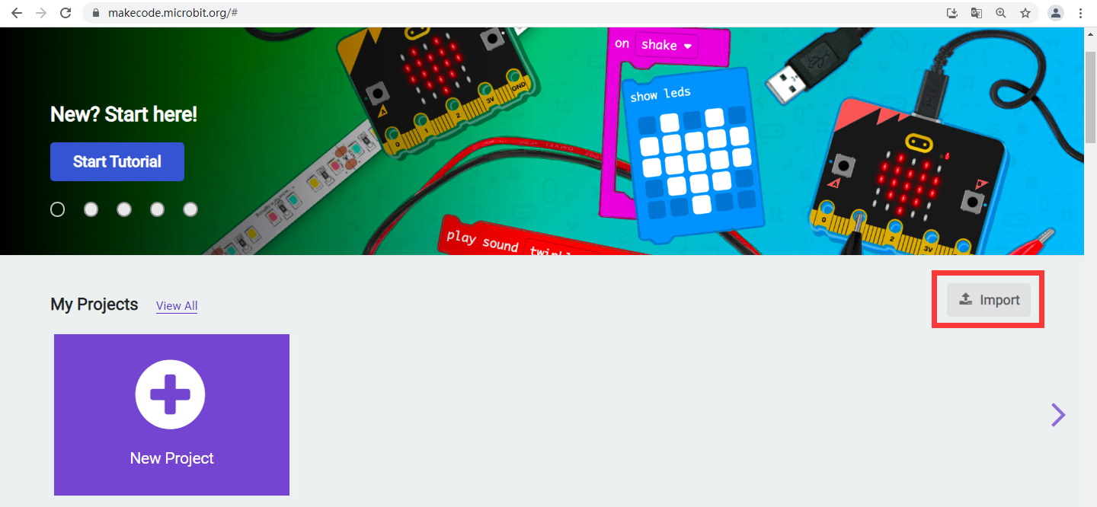

Switch to the JavaScript programming interface to refresh the extension package:

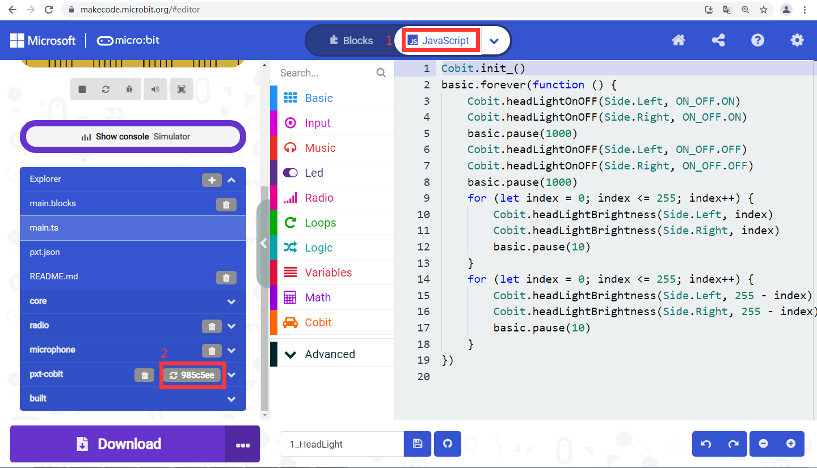

## **8.5 Analysis of Makecode Statement Based on Cobit**

Cobit-based Makecode statements are all integrated in the Cobit extension package. Simply drag and drop to the micro:bit code editing area to use. The statement analysis is as follows:

|  |  |
| --- | --- |
| **Statement** | **Analysis** |
|  | The Cobit internal device initialization statement must be initialized once in "on start". |
| Car | |
|  | Cobit writing statement, the first parameter is any character in the ASCII displayable characters, and the second parameter is the size of the font. |
|  | Cobit stop running statement. |
|  | Cobit car continuous driving statement, the first parameter is the direction, and the second parameter is the speed. |
|  | Cobit car precise distance travel statement, the first parameter is the direction, the second parameter is the travel distance, and the third parameter is the speed. |
|  | Cobit car precise steering statement, the first parameter is the direction, the second parameter is the rotation angle, and the third parameter is the speed. |
|  | In the stepping mode, the car has a delay based on the travel distance and speed. |
|  | In the stepping mode, the car has a delay based on the rotation angle and speed. |
| Wheels | |
|  | Cobit wheel mode selection statement, the first parameter is wheel selection; the second parameter is mode selection, Step mode is stepping mode, which can carry out precise driving, Continue mode is continuous driving mode, and the driving distance, distance and rotation angle are not controllable . |
|  | Cobit wheel steering selection statement, the first parameter is wheel selection, and the second parameter is steering selection. |
|  | Cobit wheel speed selection, the first parameter is wheel selection, and the second parameter is speed selection. |
|  | Cobit wheel precise rotation angle setting, the first parameter is wheel selection, and the second parameter is rotation angle setting. |
|  | Cobit wheel precise rotation distance setting, the first parameter is wheel selection, and the second parameter is driving distance setting. |
|  | Cobit wheel status selection, the first parameter is wheel selection, and the second parameter is stop or brake status selection. |
|  | When the wheels are in stepping mode, the delay is based on the travel distance and speed. |
|  | When the wheel is in step mode, the delay is based on the rotation angle and speed. |
| Sonar | |
|  | The Sonar switch state setting of the Cobit car. |
|  | Return the Sonar measurement distance data of the Cobit car. |
| IRremote | |
|  | Return the data received by the infrared receiving sensor of the Cobit car. |
|  | The key value of the infrared remote control. |
| Buzzer | |
|  | The buzzer switch state setting of the Cobit car. |
|  | Set the frequency of the buzzer. |
|  | Set the volume of the buzzer. |
| Servo | |
|  | Cobit car steering gear interface off state setting. |
|  | Set the rotation angle of the servo. The first parameter is the selection interface, and the second parameter is the rotation angle. |
| Headlight | |
|  | Headlight switch state setting, the first parameter is car light selection, and the second parameter is switch state selection. |
|  | Headlight brightness setting, the first parameter is car light selection, and the second parameter is brightness. |
| PR | |
|  | Read the photoresistor data, the parameter is photoresistor selection. |
| LineDetection | |
|  | Read the data of the line-detection sensor, the parameter is the line-detection sensor selection. |
| RGB | |
|  | RGB light brightness setting. |
|  | RGB color, the first parameter is RGB light selection, and the second parameter is color selection. |
|  | RGB light arbitrary color settings, the first parameter is RGB light selection, the second 2---3 parameters are the corresponding red, green, and blue color settings, by adjusting the values ​​of these three parameters, the RGB lights can emit different colors of light. |
| Voltmeter | |
|  | Read the battery voltage of the Cobit car. |
|  | Read the battery percentage of the Cobit car, and 0---100% is mapped to 6.5V---8.4V. |
| Port | |
|  | Set the reserved IO port mode of the Cobit car. The first parameter is IO port selection, and the second parameter is IO mode selection. |
|  | Read IO output level setting, the first parameter is IO port selection, and the second parameter is IO output level setting. |
|  | D11 IO port outputs PWM signal, the parameter is 0---255. |
|  | Read the digital value of the IO port, and the parameter is IO port selection. |
|  | Read the analog value of the IO port, and the parameter is the IO port selection. |

## **8.6 Example Tutorial**

The source code of all Makecode examples is stored in the "Makecode" folder. Please open the makecode online programming webpage when you need to view it.：<https://makecode.microbit.org/>



Then use the "Import" menu to import the required examples from the "Makecode" folder.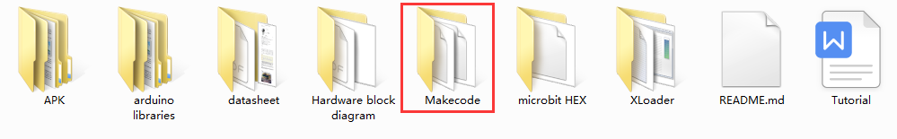

You can also open the "Makecode" folder, select the file in need, and then click the right mouse button to send the sample HEX file directly to the micro:bit motherboard, and then check the phenomenon.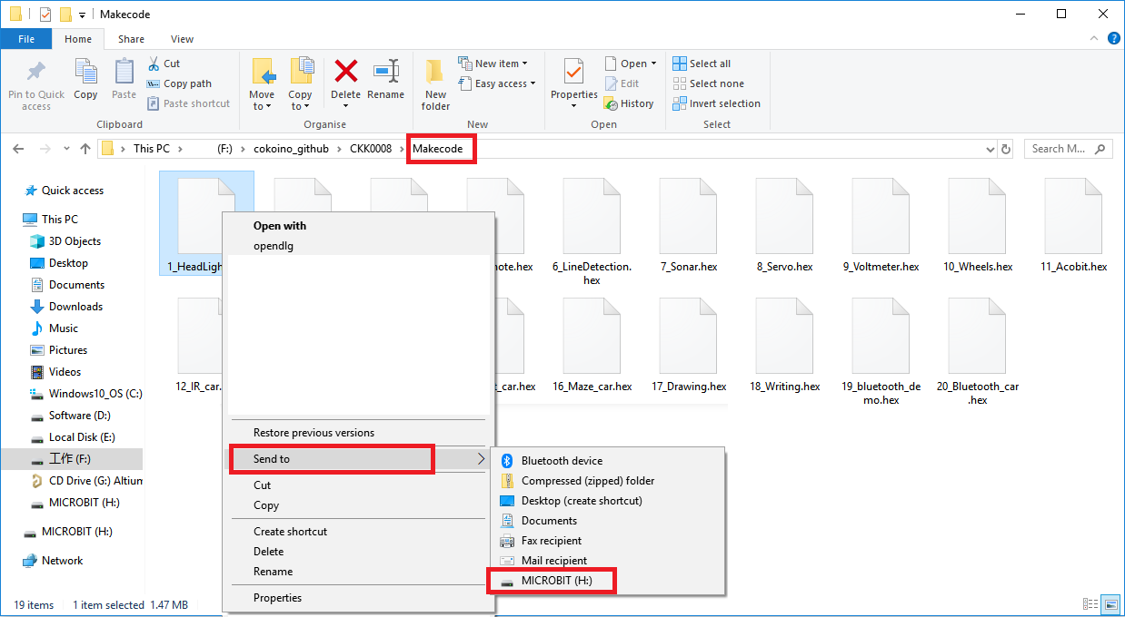

### Please note that the following example is based on the "microbit" code of arduino burned by the cobit, otherwise it will not work. For specific operations, please refer to the "Cobit Uses Micro:bit for Programming" chapter.

### 1\_Examples of headlights



Cobit Integrats two white 5MM headlights, the "Headlight" example provides control of their on and off states. You can also control their brightness, this function can achieve the effect of breathing light.

The brightness of the light is controlled by a PWM signal. PWM means pulse width modulation, that is, pulses with variable high and low time widths are periodically generated.When the high level is high, the headlights will be on, and when the low level is low, the headlights will be off. For example, the period of a pulse is 255 milliseconds (period = high level time + low level time), when the high level time width is 255 milliseconds , The low-level time width is 0, and the headlights are the brightest at this time; when the high-level time width is 0 and the low-level time width is 255 milliseconds, the headlights are the darkest at this time. After uploading the code, the two headlights of Cobit will light up for 1 second and then turn off; then the breathing light will turn on, and then the breathing light will turn off; and keeps working like this.

### 2\_Buzzer



Cobit has a passive buzzer. When the passive buzzer has been supplied with direct current, the buzzer will not make sound, and some will cause the buzzer to become hot. In severe cases, the buzzer will be damaged. Give the passive buzzer a signal source with frequency to produce a sound. The "Buzzer" example provides the control of the passive buzzer on and off, and can also adjust its volume and sound frequency (20---1000 Hz).

After uploading the code, the buzzer will emit a sound of 20---1000 Hz, and keeps working like this.

### 3\_Examples of Photoresistors

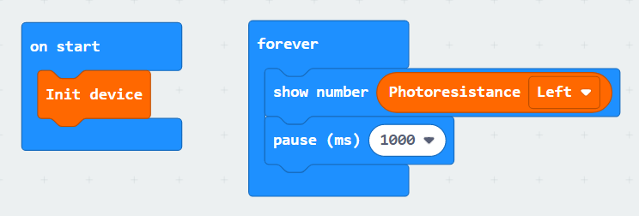



The Cobit front end integrates two photoresistors, and the "PR" example can read their analog values.

Photoresistor is a component that converts light signals into electrical signals. The stronger the luminosity, the smaller the resistance of the photoresistor. After uploading the code, open the serial monitor of the arduino IDE, set the baud rate to 9600, and the monitor will print the data of the two photoresistors.

### 4\_RGB light example

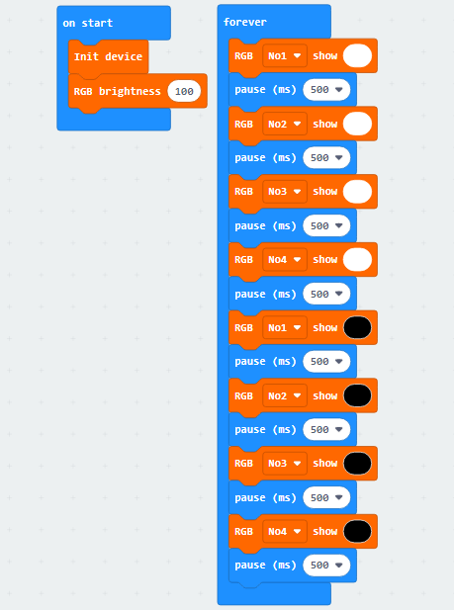



Cobit has 4 RGB lights, which can emit red, green, and blue lights. By controlling the brightness of the three lights, and then combining with each other can produce light of various colors.

After uploading the code, 4 RGB lights will turn on (white light), and then turn off.

### 5\_Infrared receiver example



There is an infrared receiving sensor on the front and rear of the Cobit. This design makes the dead angle of the Cobit smaller when receiving data, and the received data is more accurate and more sensitive. The data received by "IR Value" is processed, only the lower 8 bits (0---255) of the data.

After uploading the code, the 5\*5 dot matrix on the micro:bit motherboard will display the received key value of the infrared remote control.

Infrared remote control key value:

|  |  |  |  |  |  |  |  |  |  |
| --- | --- | --- | --- | --- | --- | --- | --- | --- | --- |
| Key | 0 | 1 | 2 | 3 | 4 | 5 | 6 | 7 | 8 |
| Key value | 0x67 | 0x5D | 0x9D | 0x1D | 0xDD | 0xFD | 0x3D | 0x1F | 0x57 |
| Key | 9 | \* | # | ▲ | ▼ | ◀ | ▶ | OK |  |
| Key value | 0x6F | 0x97 | 0x4F | 0xE7 | 0xB5 | 0xEF | 0xA5 | 0xC7 |  |

### 6\_Example of Infrared Black and White Line Detection

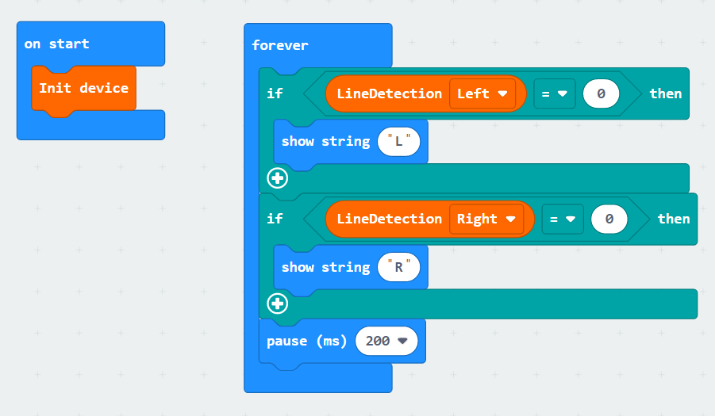

Two infrared pair tube line tracking sensors are integrated at the bottom of the Cobit, and the initial default output is high level. The infrared pair tube is divided into two parts, one is the infrared transmitting end, the other is the infrared receiving end, the infrared transmitting end transmits infrared signals, and the receiving end receives the infrared signals reflected back after hitting an object.

The black line has a good absorption effect on infrared rays. When the infrared rays are emitted from the transmitting end of the tube patrol sensor to irradiate the black line, the infrared rays are absorbed without forming a reflected signal, and the receiving end does not receive a signal, and the line patrol sensor outputs a high level (1); When the white line is irradiated, because the white line has no absorbing effect on infrared rays, the infrared signal is reflected back, the receiving end receives the signal, and the line-following sensor outputs low level (0).

After uploading the code, the 5\*5LED dot matrix of the microbit will display "R" when a white object is used to block the line-following sensor on the right, and "L" when blocking the left.

### 7\_Sonar Example





Ultrasonic is a mechanical wave with an extremely short wavelength. The wavelength in the air is generally shorter than 2 cm (centimeters). It must rely on the medium to propagate and cannot exist in a vacuum (such as space). But because of its short wavelength, it is easily lost and scattered in the air. It is not as far as audible sound and infrasound waves. However, the short wavelength is easier to obtain anisotropic sound energy, which can be used for cleaning, ranging, etc.

A sonar port is reserved on the Cobit, which can be connected to the HC-RS04 ultrasonic module for distance measurement. Cobit is equipped with the HC-RS04 ultrasonic module by default, and integrates the module's API in the Cobit library. The measurement data of the module can be read by using the API, which greatly reduces the difficulty of use. The maximum measuring distance is 255cm, and the accuracy is +/-1CM.

After uploading the code, place an obstacle directly in front of the Cobit, and the 5\*5LED dot matrix of the microbit will display the distance between the Cobit and the obstacle, and the data unit is cm.

### 8\_Servo Example





There are 3 servo drive ports reserved on the Cobit, which can be connected with Lego or SG90 servos.

After uploading the code, connect the servo to any servo port, and the servo will swing back and forth between 0---180 degrees.

舵机知识：

①Power negative (black), power positive (red), signal (yellow);

②Potentiometer: can measure the position of the output shaft, which belongs to the feedback part of the entire servo mechanism;

③Internal controller: processing signals from external control, driving motors and processing feedback position signals are the core of the entire servo mechanism;④Motor: as an actuator, how much speed, torque, and position are output by it;

⑤Transmission mechanism / servo system: This mechanism scales the stroke of the motor output to the angle of the final output according to a certain transmission ratio



The output of the servo is controlled by sending a PWM signal to the signal line of the servo. The period and duty ratio of the PWM are controllable, so the duty ratio of the PWM pulse directly determines the position of the output shaft.

Here is an example:

When the pulse width is 1ms, the output shaft of the servo will move to the smallest position (0 degrees);

When the pulse width is 1.5ms, the output shaft of the servo will move to the middle position (90 degrees);

When the pulse width is 2ms, the output shaft of the servo will move to the smallest position (180degrees)

### 9\_Voltmeter example



A voltmeter is designed on Cobit to read battery voltage and voltage percentage. The voltage percentage is a mapping value:

|  |  |
| --- | --- |
| Range of Voltage | Mapped Voltage Percentage |
| 6.5V---8.4V | 0---100% |

After uploading the code, put two 18650 lithium batteries into the battery box of the Cobit, turn the power switch to the "ON" state, the 5\*5LED dot matrix of the microbit motherboard will print the voltage value and voltage percentage of the two lithium batteries in series out.

### 10\_Wheels Example



There is a wheel with a diameter of 65mm on the left and right sides of the Cobit. Two stepper motors are used as the power of the wheel. The rotation angle and the rotation arc of the wheel can be controlled. The rotation angle accuracy is +/-0.9 degrees, and the rotation speed is divided into 0-- -4 gears (0 = 0rpm, 1 = 15rpm, 2 = 30rpm, 3 = 60rpm, 4 = 120rpm).

After uploading the code, the two motors on the left and right of Cobit first rotate 360 ​​degrees clockwise, and then rotate counterclockwise for 3 seconds, and then continue like this.

### 11\_Basic operation of Cobit



How to create the makecode function:：

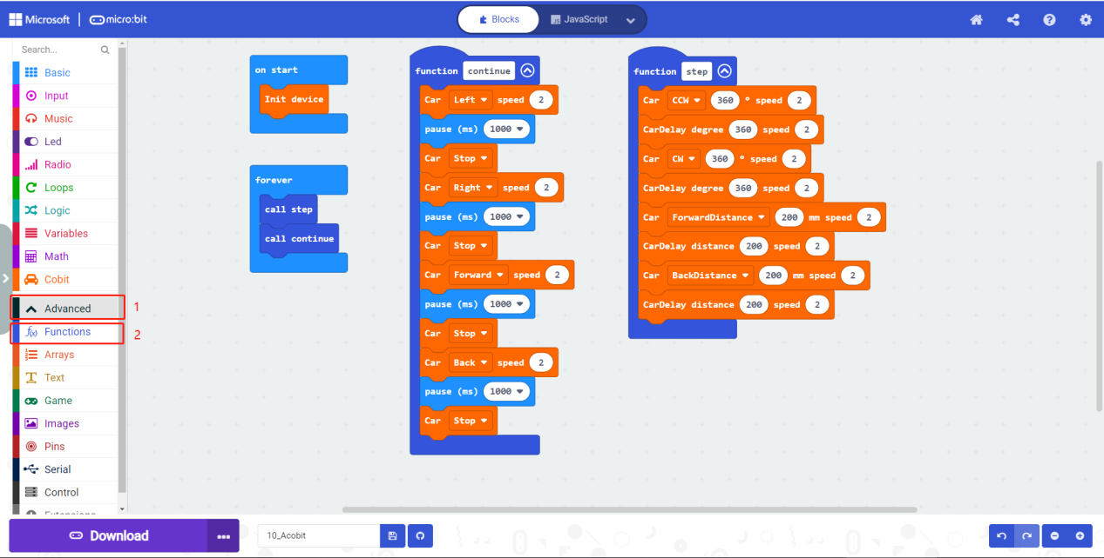

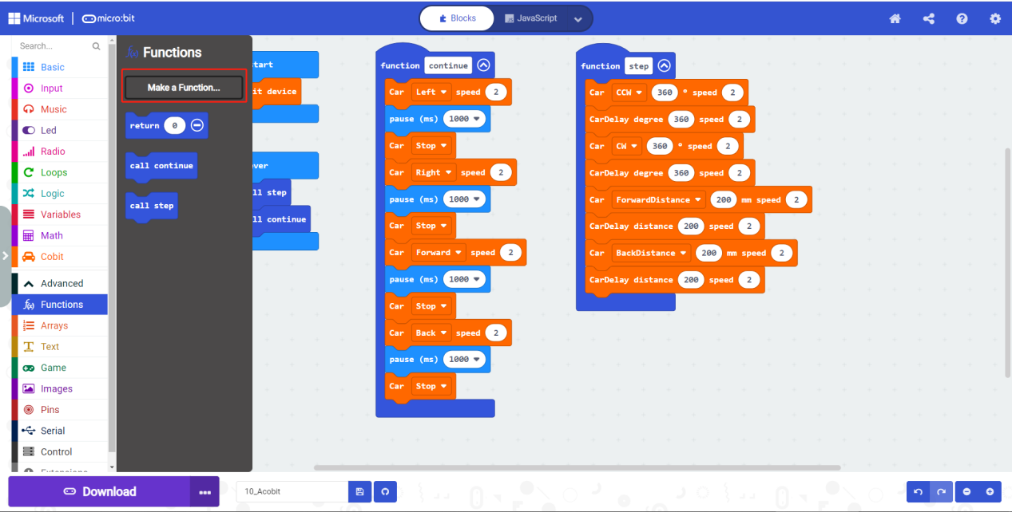

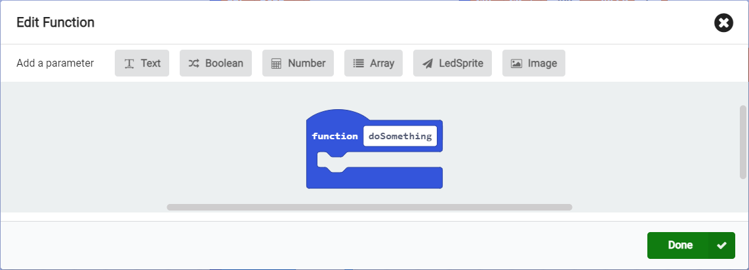

This example includes the basic driving operations of Cobit, such as the steering, driving direction of the car and their corresponding delay functions.

After uploading the code, Cobit will turn 360 degrees, turn right 360 degrees, drive 200mm forward, and then reverse 200mm; then turn left continuously for 2 seconds, turn right continuously for 2 seconds, and drive forward for 1 second, then Go back for 1 second, and then keeps like this.

### 12\_Infrared remote control car

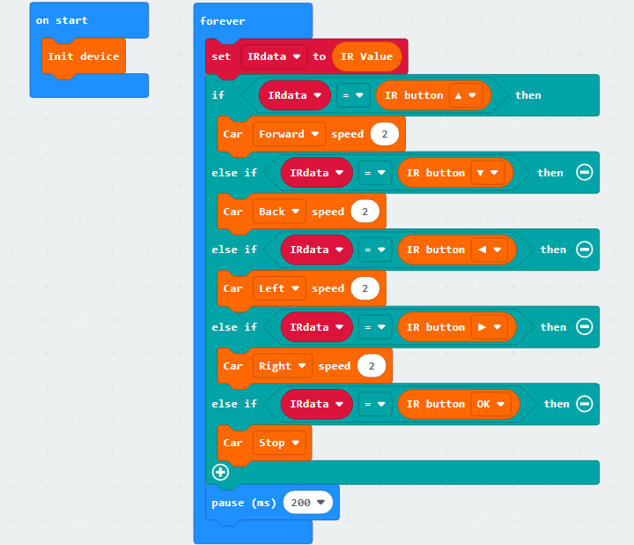



Cobit is equipped with an infrared remote control by default, and each button has a different key value. We give each key value a different function, and then send the key value to Cobit through the remote control, and Cobit obtains the key value and then implements the key Value function.

Infrared remote control key value:

|  |  |  |  |  |  |  |  |  |  |
| --- | --- | --- | --- | --- | --- | --- | --- | --- | --- |
| Key | 0 | 1 | 2 | 3 | 4 | 5 | 6 | 7 | 8 |
| Key Value | 0x67 | 0x5D | 0x9D | 0x1D | 0xDD | 0xFD | 0x3D | 0x1F | 0x57 |
| Function | null | null | null | null | null | null | null | null | null |
| Key | 9 | \* | # | ▲ | ▼ | ◀ | ▶ | OK |  |
| Key Value | 0x6F | 0x97 | 0x4F | 0xE7 | 0xB5 | 0xEF | 0xA5 | 0xC7 |  |
| Function | null | null | null | forward | back | turn left | turn right | stop |  |

### 13\_Line Detection Car

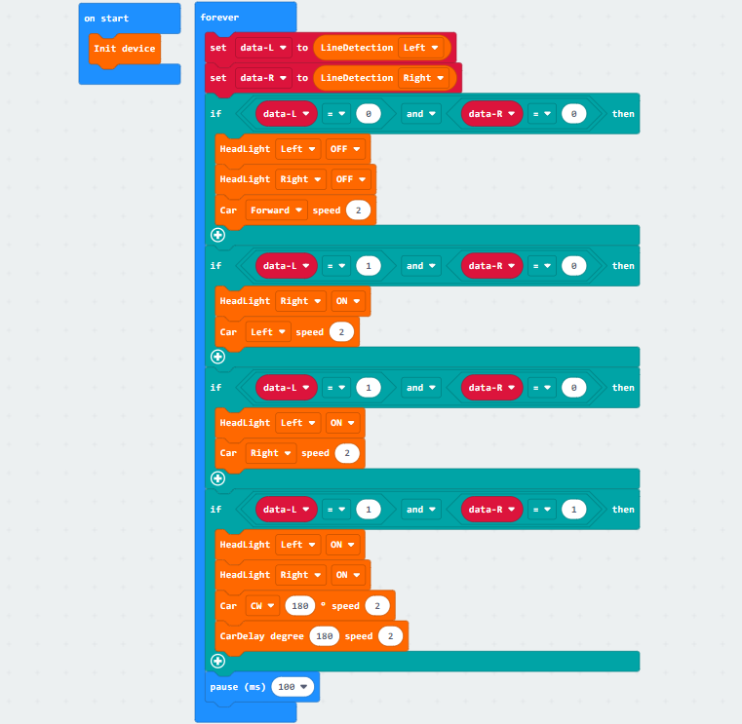



The car is with function of the infrared line Detection. Use 2 cm wide black paper cloth on the white black paper to form a line of track shape. Black objects have the effect of absorbing infrared rays, and white objects have the effect of reflecting infrared rays. Use this function You can keep the car walk along the black line.



is“0”，is“1”.

### 14\_Line Detection Restricting





Line Detection Restricting function realized by infrared line Detection sensor. After burning the code, stick a square with black tape on the white paper, and put the car into the square. When the car is driving in the square, the two infrared line patrol sensors keep receiving the reflected signal, it means that the car is still on the desktop. When the car hits the black line, the line-following sensor does not form a reflection signal, and the car immediately brakes to stop, and then turns direction to travel.

### 15\_PR Car

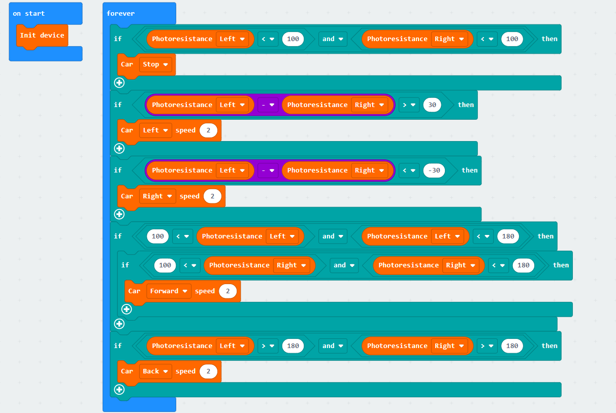



A photoresistor sensor is integrated on the left and right sides of the Cobit, which can be used to determine the brightness of the light on both sides of the Cobit, and then the motor rotates to make the light brightness obtained by the photoresistor sensors on both sides of the Cobit basically the same, so that the Cobit always keeps facing the light source. Follow the light source.

Note: In order to avoid the influence of other light, please carry out this experiment in a dark place.

### 16\_Sonar Car

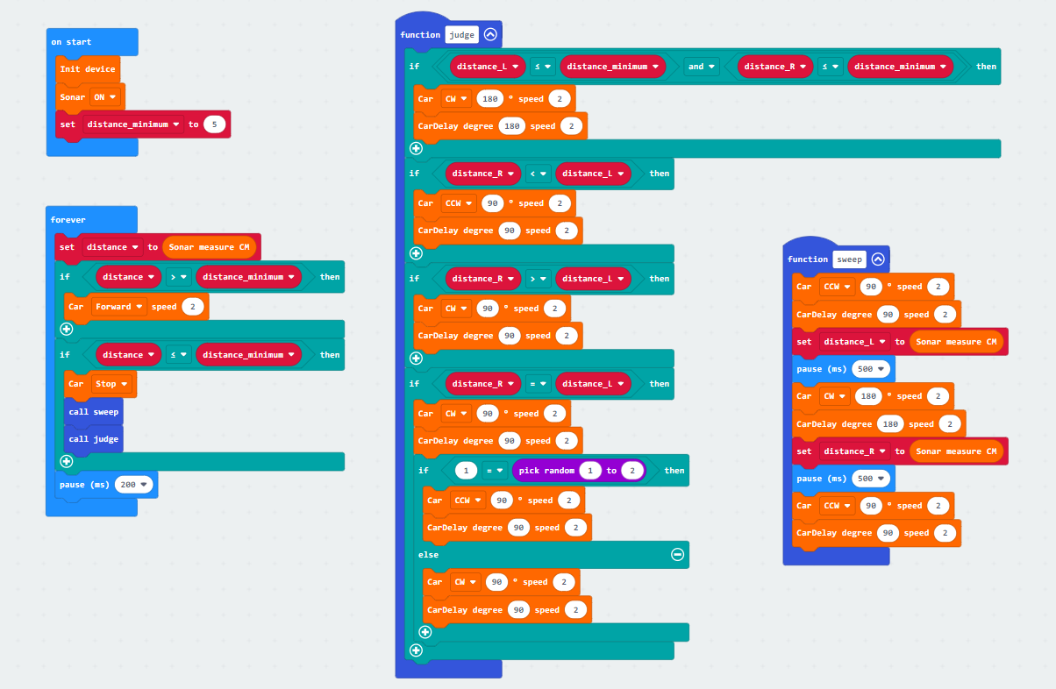

Remarks: The examples use functions. For specific implementation, please refer to the 11th example in Chapter 8.7.

We provide the Sonar module for the Cobit car by default. As long as the module is inserted into the sonar interface of the Cobit, the Cobit has the function of measuring distance.

The function of this code is to use the ultrasonic sensor on the front end of the Cobit to measure the distance of the obstacle in front. If the distance is less than the distance set by the program, the car will stop immediately, and then turn to measure the distance of the obstacles on the left and right sides, and select the farthest distance and greater than the minimum distance If the left and right distances are less than the minimum distance, the car will make a U-turn.

### 17\_Drawing Car



Remarks: The examples use functions. For specific implementation, please refer to the 11th example in Chapter 8.7.

This function of the Cobit is completed in conjunction with Lego accessories. There are standard Lego mounting holes reserved on the car body. As long as the pen holder structure is built according to the assembly instructions, the Cobit can paint then.

Burn the code into the Cobit and place the Cobit on the upper left corner of the A4 paper. The cart will draw a rectangle on the paper. If you need more shapes, you can refer to the code programming.

### 18\_Writing Car

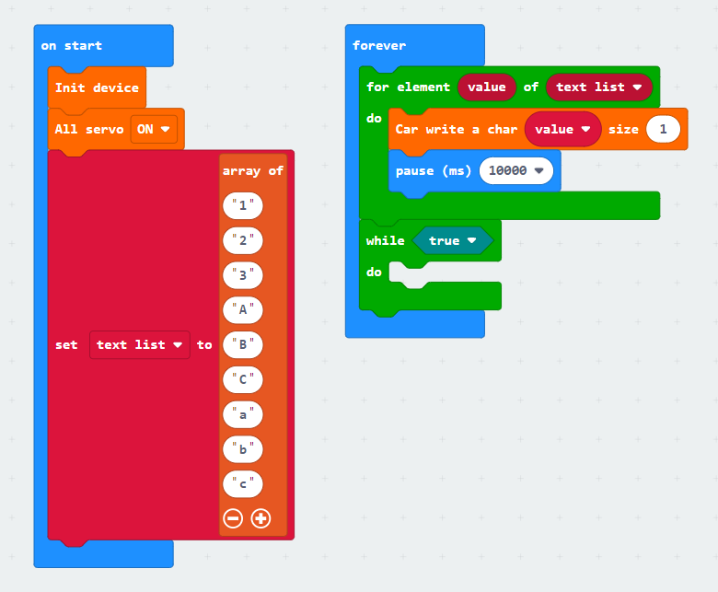

This example is completed with Lego accessories. The car body has standard Lego mounting holes. You need to build the Lego pen holder structure according to the assembly instructions to enable the Cobit to have the writing function.

Burn the code into the Cobit, stitch together 3 sheets of A4 paper, put the Cobit on the upper left corner of the first A4 paper, the car will write "123ABCabc" on the paper, you can also fill in the sample code string you need.



### 19\_Bluetooth Port Example

Micro:bit V1 integrates a Bluetooth 4.1 stack, Micro:bit V2 integrates a Bluetooth 5.0 stack, and the communication frequency band is 2.4G---2.41G, which enables the micro:bit motherboard to communicate with the Bluetooth of the mobile phone to achieve wireless control functions.

Bluetooth hardware technical documents:

<https://tech.microbit.org/bluetooth/>

Bluetooth syntax usage tutorial:

<https://makecode.microbit.org/reference/bluetooth>

Tutorial video of connecting Bluetooth official website:

<https://makecode.microbit.org/reference/bluetooth/on-bluetooth-connected>

**BitApp is paired with Micro:bit V1/2**

Open <https://makecode.microbit.org> Create a new online project:

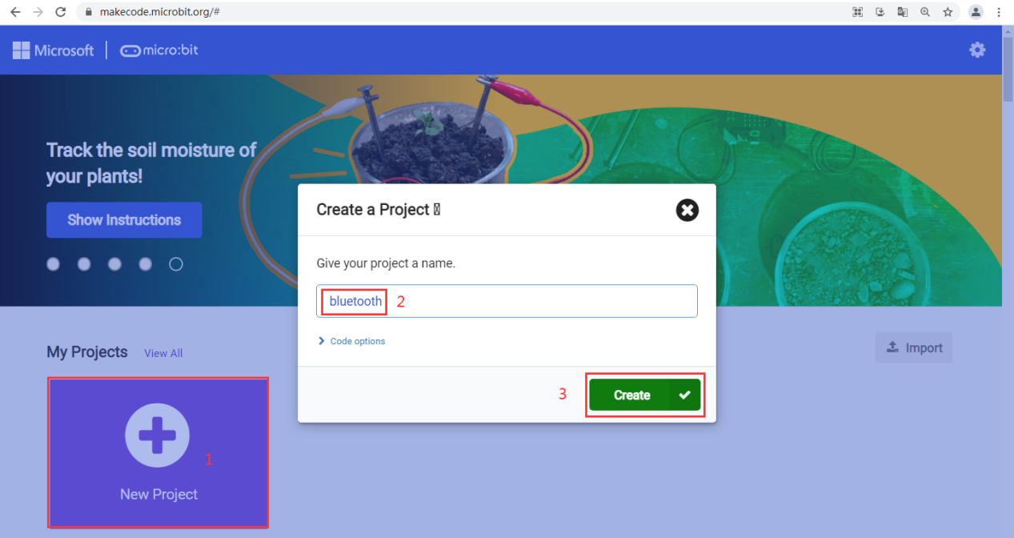

After creating a new project, you need to import the Bluetooth extension package. Because the Bluetooth expansion board and the micro:bit default "Radio" expansion are not compatible with the micro:bit motherboard at the same time, you will be prompted to delete the "Radio" expansion board during the process of adding the Bluetooth expansion package. Please confirm the deletion at this time (if you need to use the "Radio" expansion package can also be added back).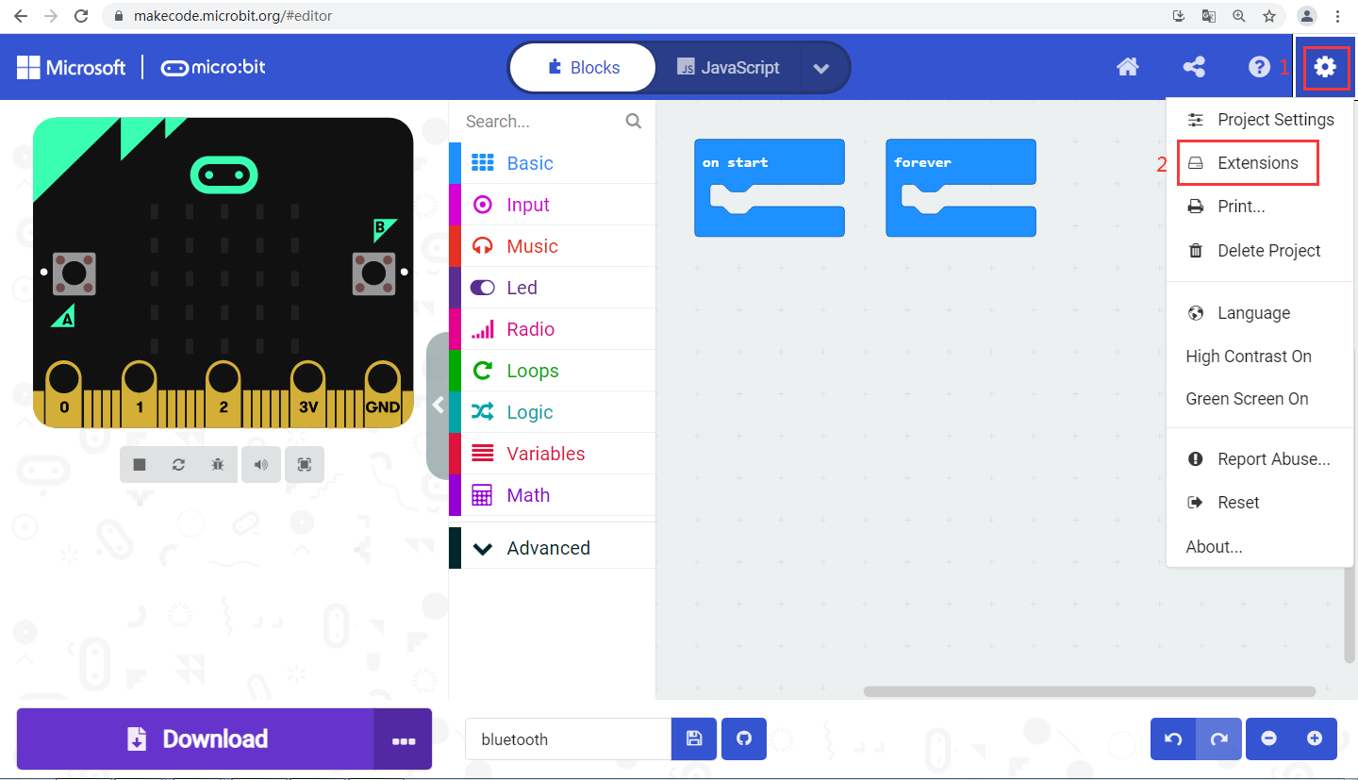

**---------------------------------------------------------------------------------------------------------------------------------**

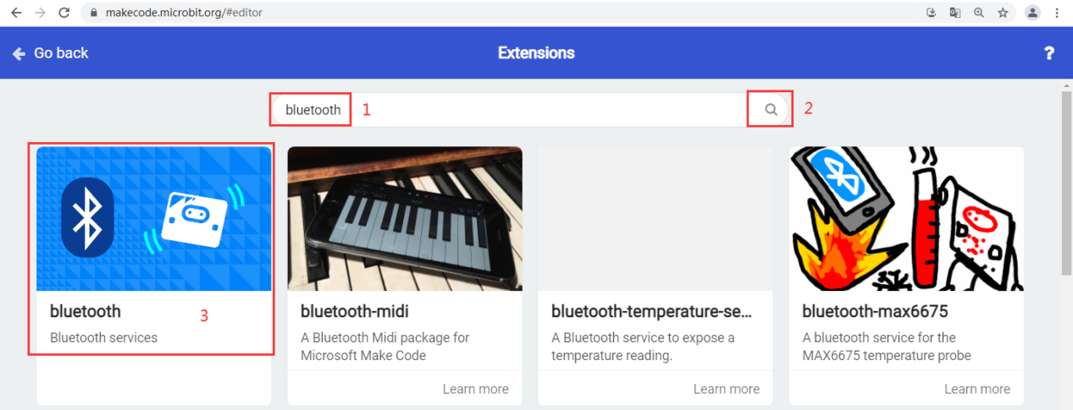

**---------------------------------------------------------------------------------------------------------------------------------**

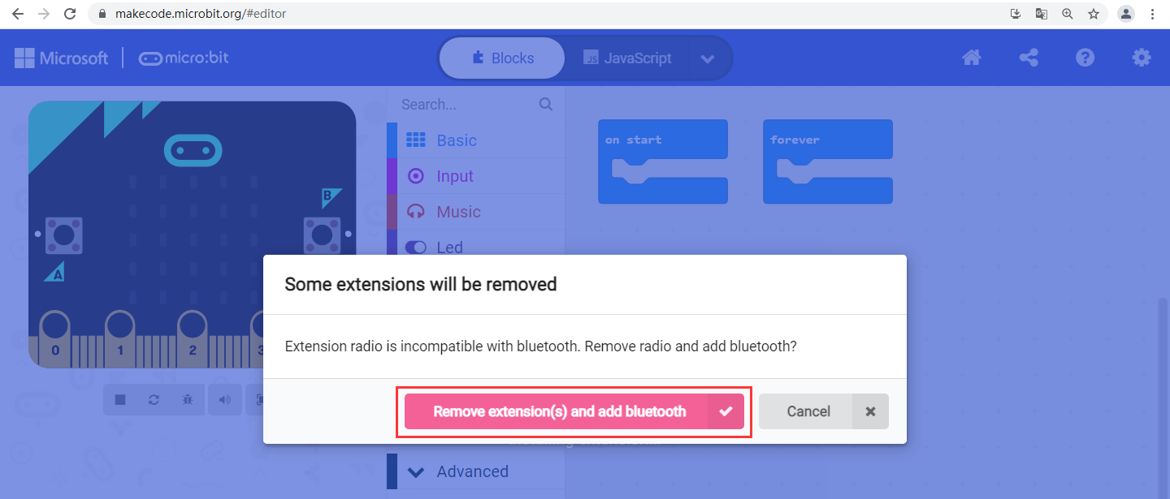

After installing the Bluetooth expansion package, you can use the Bluetooth function of the micro:bit normally. Here we then program to display "√" on the micro:bit 5\*5 LED dot matrix when the mobile phone is paired with the Bluetooth of the micro:bit.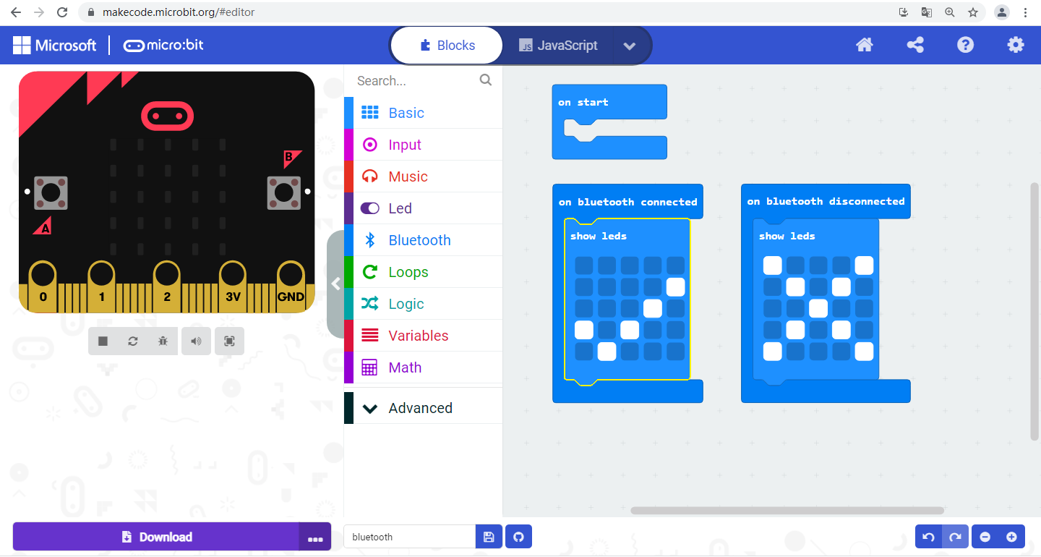

The project has 4 working modes, we need to select the required working mode according to the actual needs of the project, here we select the "No Pairing Required: Anyone can connect via Bluetooth." mode. and then save.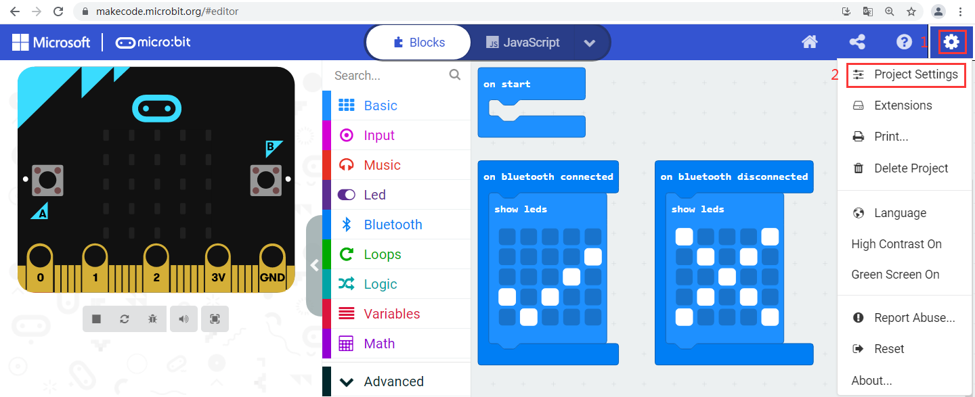

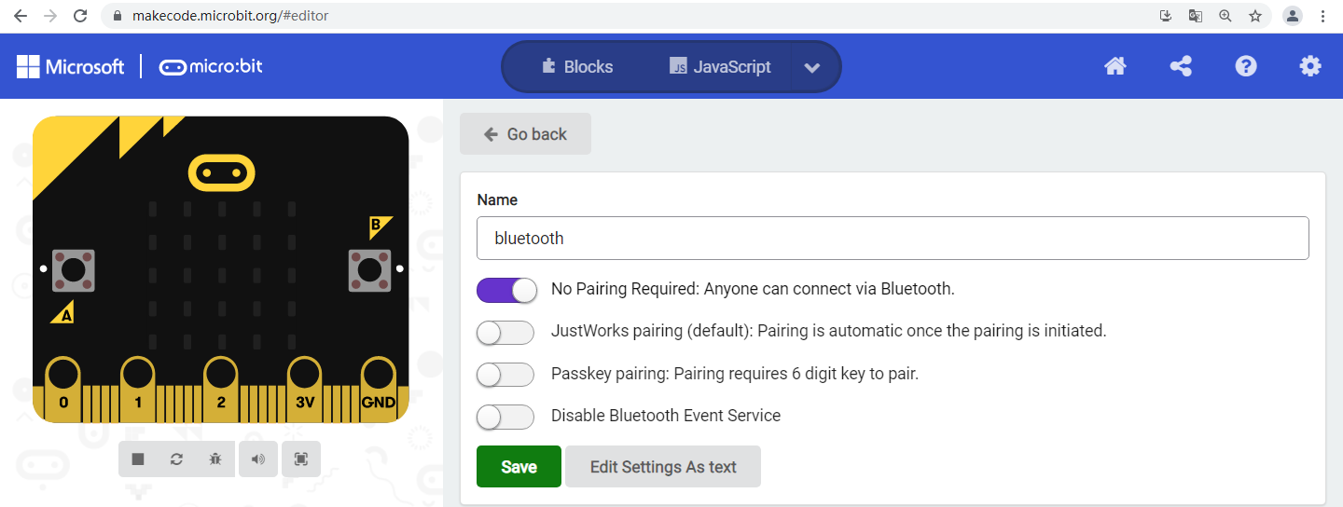

After setting the mode, connect the micro:bit device, then generate the HEX file from the project, and upload the HEX file to the micro:bit,

There are two ways to upload the HEX file of the micro:bit.

**Method 1 (systems above windows8)**

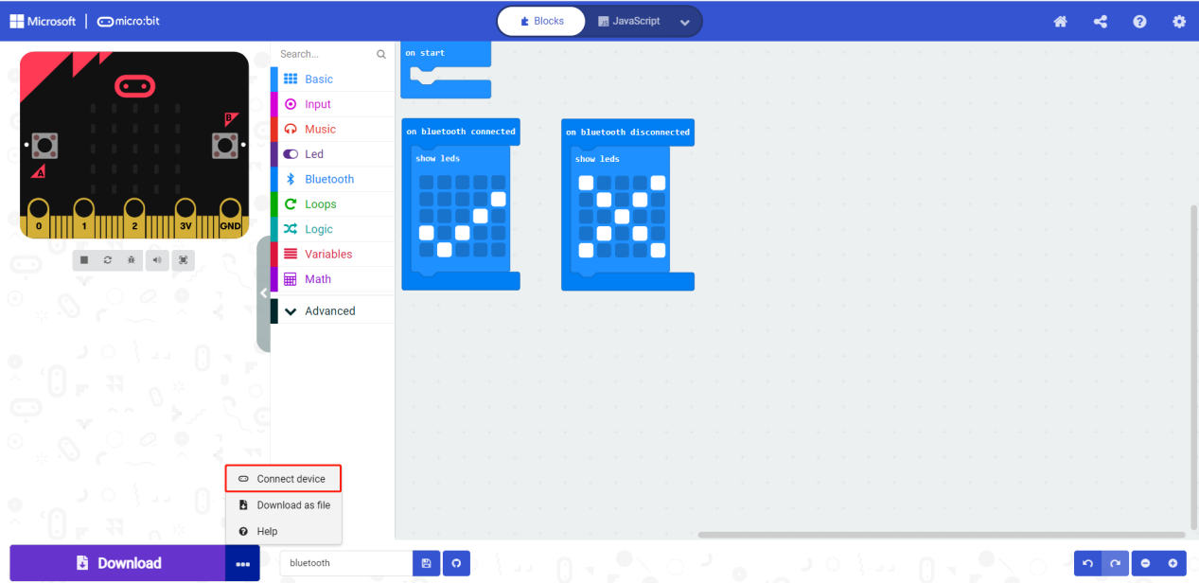

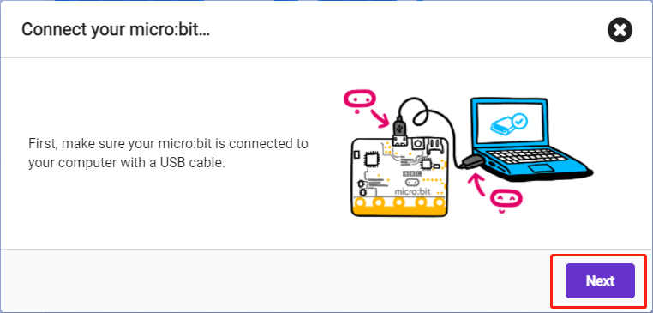

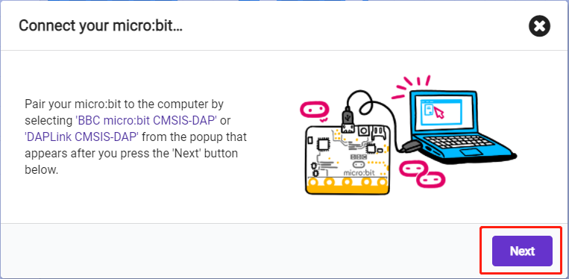

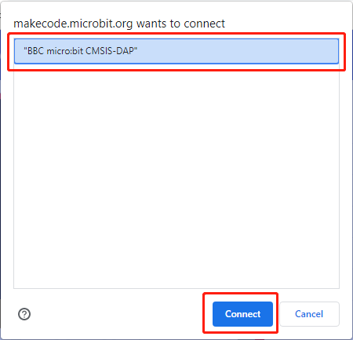

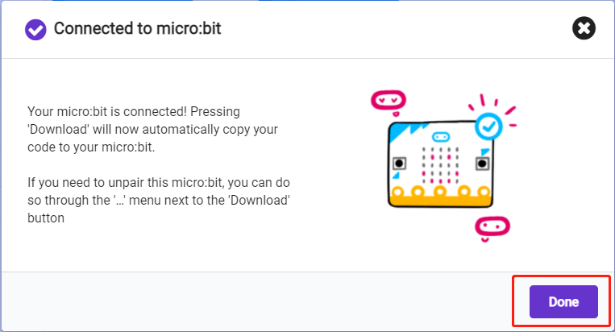

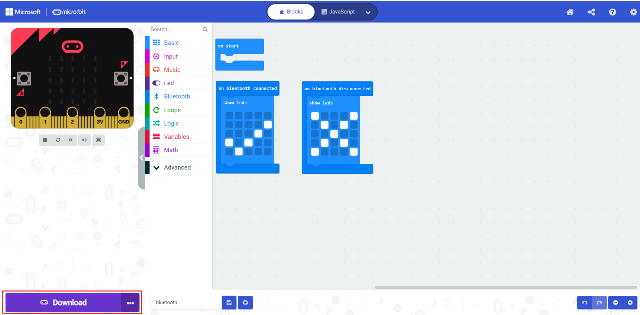

**Method 2**

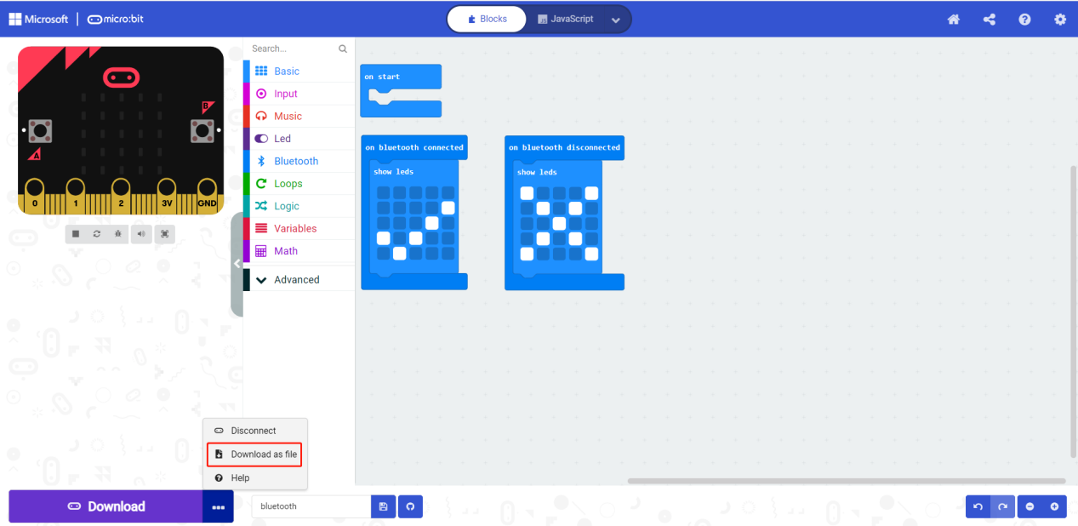

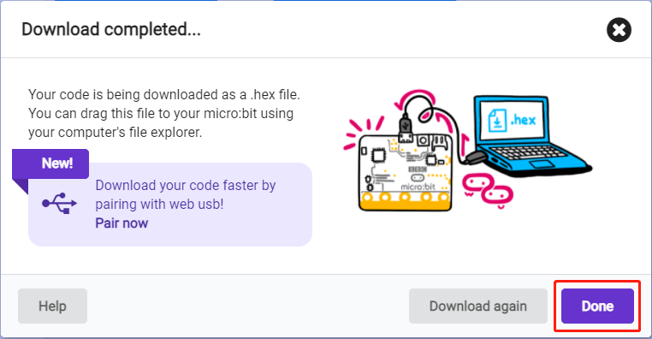

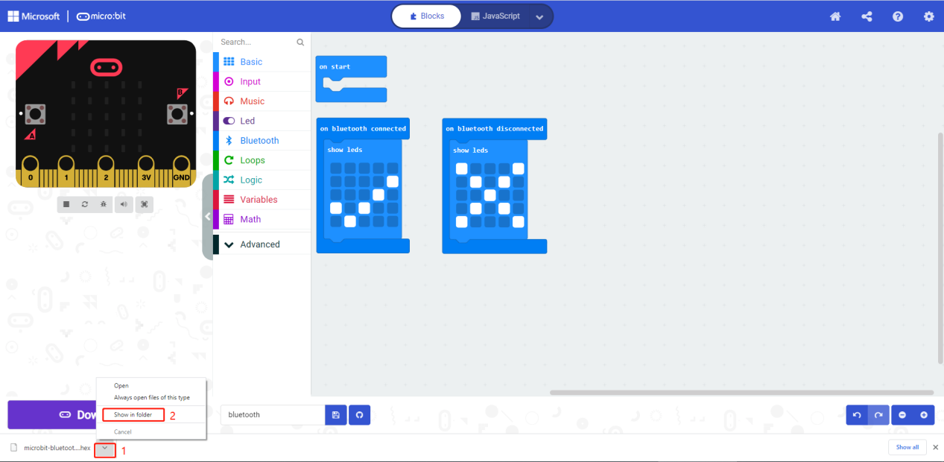

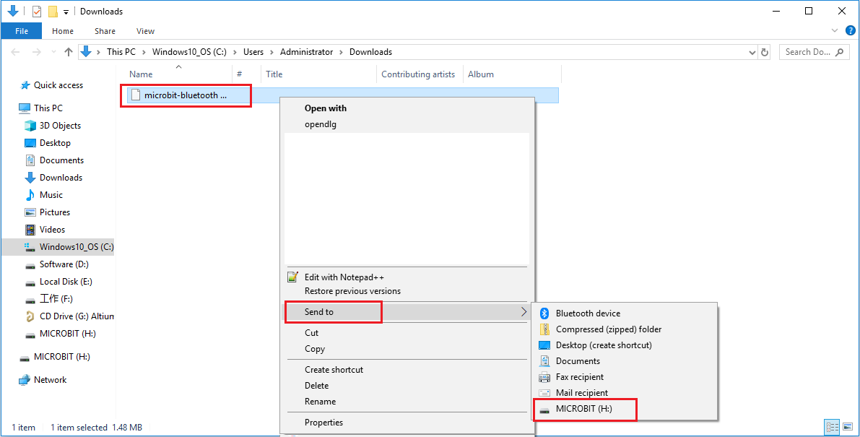

Then open BitApp, search and pair Bluetooth (for more details, please refer to the "BitApp" chapter).

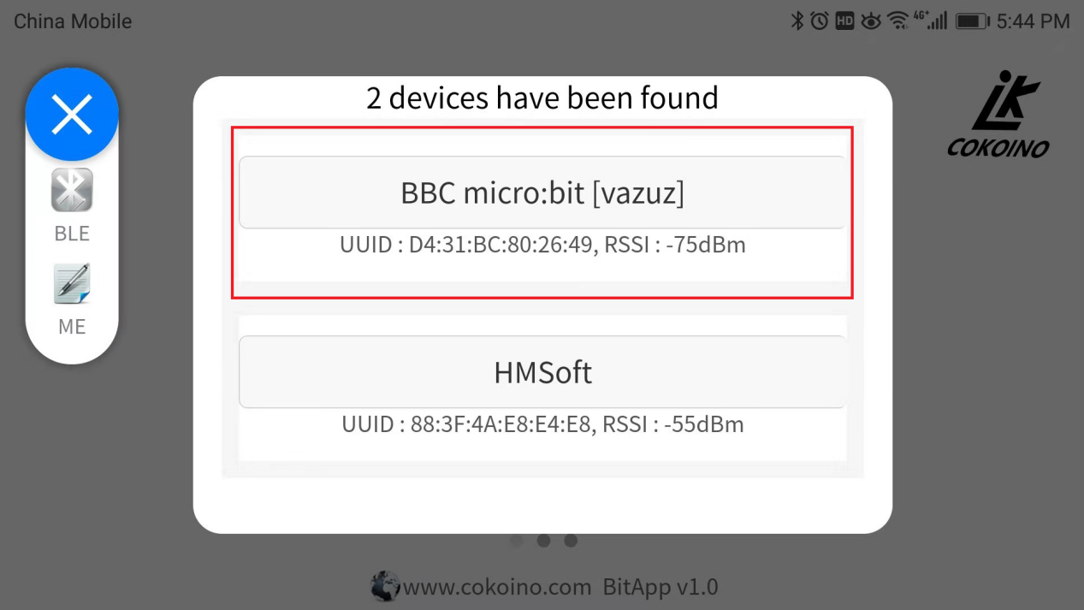

When the pairing is successful, the 5\*5 LED dot matrix of the micro:bit displays "√".

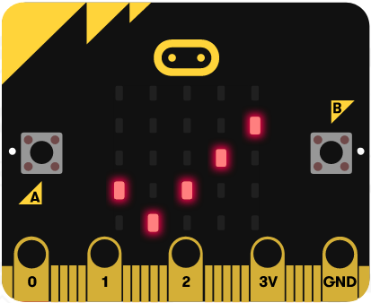

We also have a simple communication example. The code is stored in the "makecode" folder. Please copy the file to the micro:bit motherboard, then connect the Bluetooth of the micro:bit motherboard, and select the control method under the Cobit image in BitApp. Click to switch to the music keyboard, and then click the music keyboard to make Cobit sing.

Sample code:

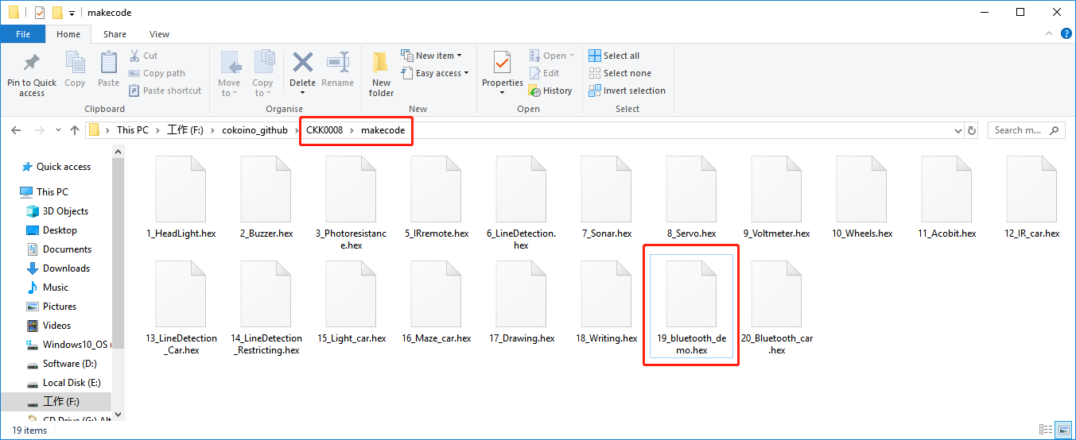

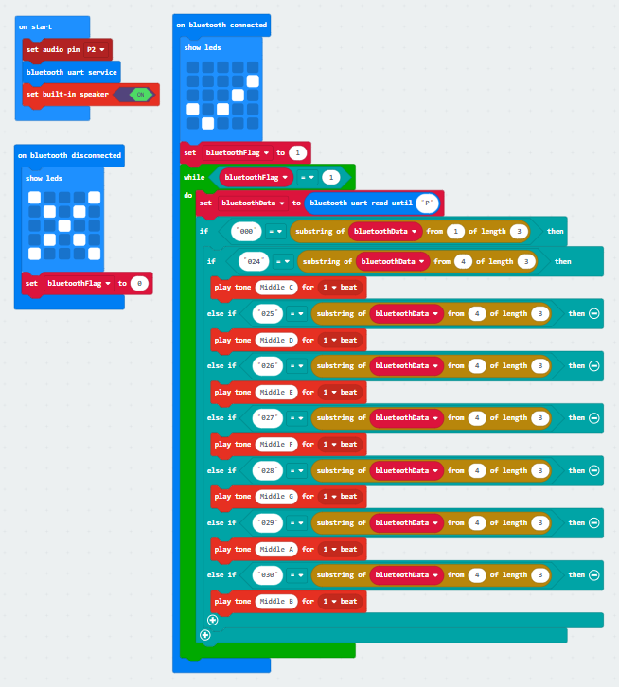

Connect to Bluetooth and select the operation mode of the Cobit icon:

|  |
| --- |
| 微信图片_20210906195447 |

Send key value:

|  |
| --- |
| 图片1 |

Music keyboard:：

|  |  |  |  |  |
| --- | --- | --- | --- | --- |
| SN | 1 | 2 | 3 | 4 |
| Function | do | re | mi | fa |
| SN | 5 | 6 | 7 |  |
| Function | sol | la | ti |  |

**Precautions for using the buzzer on the micro:bit motherboard after adding the makecode cobit expansion package:**

The expansion package is serial communication, using P0 and P1 ports, the pin of the buzzer is also the default P0 port, when using the buzzer, the pin of the buzzer must be mapped to other pins, otherwise it will affect the normal of the expansion package Use, and the buzzer switch is off by default, you need to turn it on, as shown in the figure below:

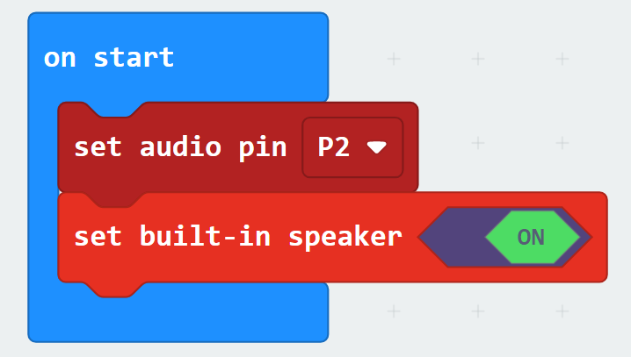

### 20\_Bluetooth remote control car

This example is a comprehensive example. If the graphics code is too large, no screenshots will be taken. The code is stored in the "Makecode" folder: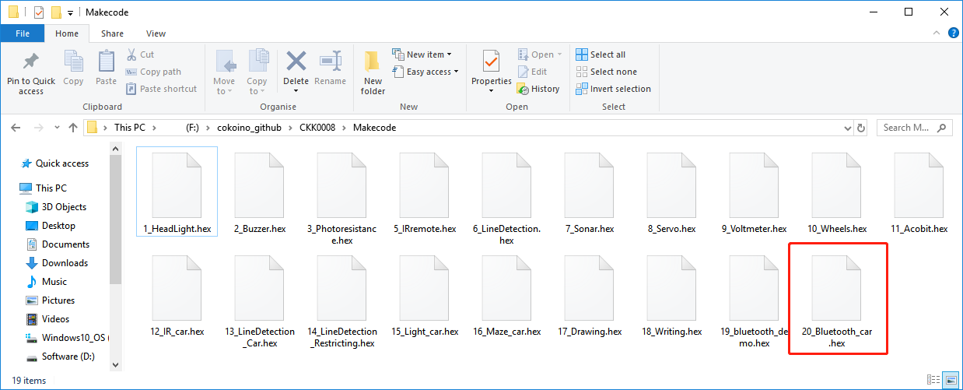

To view the source code, please import the online programming webpage:



Use BitApp to connect to the Bluetooth on the micro:bit motherboard, select the operation mode under the Cobit image, and then press the following key instructions to operate.

|  |
| --- |
| 微信图片_20210906195447 |

Key value and function:



|  |  |  |  |  |  |
| --- | --- | --- | --- | --- | --- |
| SN | 1 | 2 | 3 | 4 | 5 |
| Function | back | forward | turn left | turn tight | return |
| SN | 6 | 7 | 8 | 9 | 10 |
| Function | stop | preserved | preserved | on/off headlight | speaker |
| SN | 11 | 12 | 13 | 14 | 15 |
| Function | on/off sonar car | preserved | preserved | preserved | preserved |
| SN | 16 | 17 | 18 | 19 | 20 |
| Function | preserved | Headlight brightness | toggle key | toggle key | toggle key |



RGB color control

|  |  |  |  |
| --- | --- | --- | --- |
| SN | 1 | 2 | 3 |
| Function | red | green | blue |
| SN | 4 | 5 | 6 |
| Function | purple | Close all RGB lights | Sea green |

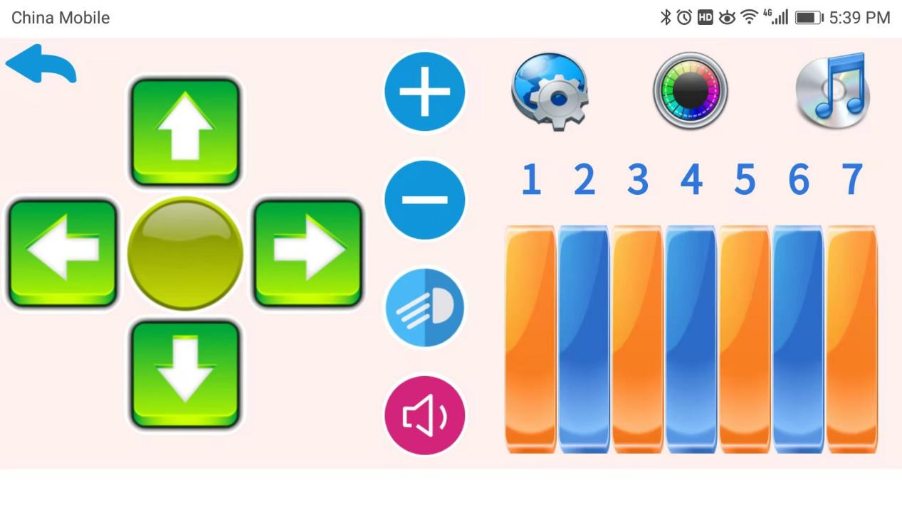

Music keyboard

|  |  |  |  |  |
| --- | --- | --- | --- | --- |
| SN | 1 | 2 | 3 | 4 |
| Function | do | re | mi | fa |
| SN | 5 | 6 | 7 |  |
| Function | sol | la | ti |  |

# **9.Getting start with Cobit for esp wifi**

The 21st century is the era of the Internet of Things. The Internet of Things has brought a lot of convenience to our lives. The esp-01 wifi port is reserved on the cobit, so that the cobit can access the Internet of Things.

## **9.1 ESP-01 wifi**



ESP-01 can be widely used in various IoT applications, suitable for home automation, industrial wireless control, baby monitors, wearable electronic products, wireless position sensing devices, wireless positioning system signals and other IoT applications. It’s is ideal solution for the application of The Internet of Things.

**Interface definition:**



**Features**

- The smallest 802.11b/g/n Wi-Fi SOC module

- Low power 32-bit CPU, can also serve as the

application processor

- Up to 160MHz clock speed

- Supports UART/GPIO

- DIP-8 package for easy welding

- Integrated Wi-Fi MAC/BB/RF/PA/LNA

- Deep sleep current as low as 20uA

- Embedded lwIP protocol stack

- Supports STA/AP/STA + AP operation mode

- Support Smart Config/AirKiss technology

- UART baudrate up to 4Mbps

- General AT commands can be used quickly

- Supports remote firmware upgrade (FOTA)

## **9.2 The Usage of Arduino with ESP -01 wifi**

The use of Arduino and ESP-01 is based on ESP-01 burning AT firmware (factory default), ATmega328P sends AT commands through software serial (D12=RX, D13=TX) to control ESP-01 to connect to wifi to send and receive data, so as to achieve Internet of things function.

**Basic AT Commands**

[AT](https://docs.espressif.com/projects/esp-at/en/latest/AT_Command_Set/Basic_AT_Commands.html" \l "cmd-at): Test AT startup.

[AT+RST](https://docs.espressif.com/projects/esp-at/en/latest/AT_Command_Set/Basic_AT_Commands.html" \l "cmd-rst): Restart a module.

[AT+GMR](https://docs.espressif.com/projects/esp-at/en/latest/AT_Command_Set/Basic_AT_Commands.html" \l "cmd-gmr): Check version information.

[AT+CMD](https://docs.espressif.com/projects/esp-at/en/latest/AT_Command_Set/Basic_AT_Commands.html" \l "cmd-cmd): List all AT commands and types supported in current firmware.

[AT+GSLP](https://docs.espressif.com/projects/esp-at/en/latest/AT_Command_Set/Basic_AT_Commands.html" \l "cmd-gslp): Enter Deep-sleep mode.

[ATE](https://docs.espressif.com/projects/esp-at/en/latest/AT_Command_Set/Basic_AT_Commands.html" \l "cmd-ate): Configure AT commands echoing.

[AT+RESTORE](https://docs.espressif.com/projects/esp-at/en/latest/AT_Command_Set/Basic_AT_Commands.html" \l "cmd-restore): Restore factory default settings of the module.

[AT+UART\_CUR](https://docs.espressif.com/projects/esp-at/en/latest/AT_Command_Set/Basic_AT_Commands.html" \l "cmd-uartc): Current UART configuration, not saved in flash.

[AT+UART\_DEF](https://docs.espressif.com/projects/esp-at/en/latest/AT_Command_Set/Basic_AT_Commands.html" \l "cmd-uartd): Default UART configuration, saved in flash.

[AT+SLEEP](https://docs.espressif.com/projects/esp-at/en/latest/AT_Command_Set/Basic_AT_Commands.html" \l "cmd-sleep): Set the sleep mode.

[AT+SYSRAM](https://docs.espressif.com/projects/esp-at/en/latest/AT_Command_Set/Basic_AT_Commands.html" \l "cmd-sysram): Query current remaining heap size and minimum heap size.

[AT+SYSMSG](https://docs.espressif.com/projects/esp-at/en/latest/AT_Command_Set/Basic_AT_Commands.html" \l "cmd-sysmsg): Query/Set System Prompt Information.

[AT+USERRAM](https://docs.espressif.com/projects/esp-at/en/latest/AT_Command_Set/Basic_AT_Commands.html" \l "cmd-userram): Operate user’s free RAM.

[AT+SYSFLASH](https://docs.espressif.com/projects/esp-at/en/latest/AT_Command_Set/Basic_AT_Commands.html" \l "cmd-sysflash): Query/Set User Partitions in Flash.

[AT+RFPOWER](https://docs.espressif.com/projects/esp-at/en/latest/AT_Command_Set/Basic_AT_Commands.html" \l "cmd-rfpower): Query/Set RF TX Power.

[AT+SYSROLLBACK](https://docs.espressif.com/projects/esp-at/en/latest/AT_Command_Set/Basic_AT_Commands.html" \l "cmd-sysrollback): Roll back to the previous firmware.

[AT+SYSTIMESTAMP](https://docs.espressif.com/projects/esp-at/en/latest/AT_Command_Set/Basic_AT_Commands.html" \l "cmd-settime): Query/Set local time stamp.

[AT+SYSLOG](https://docs.espressif.com/projects/esp-at/en/latest/AT_Command_Set/Basic_AT_Commands.html" \l "cmd-syslog): Enable or disable the AT error code prompt.

[AT+SLEEPWKCFG](https://docs.espressif.com/projects/esp-at/en/latest/AT_Command_Set/Basic_AT_Commands.html" \l "cmd-wkcfg): Query/Set the light-sleep wakeup source and awake GPIO.

[AT+SYSSTORE](https://docs.espressif.com/projects/esp-at/en/latest/AT_Command_Set/Basic_AT_Commands.html" \l "cmd-sysstore): Query/Set parameter store mode.

[AT+SYSREG](https://docs.espressif.com/projects/esp-at/en/latest/AT_Command_Set/Basic_AT_Commands.html" \l "cmd-sysreg): Read/write the register.

**Wi-Fi AT Commands**

[AT+CWMODE](https://docs.espressif.com/projects/esp-at/en/latest/AT_Command_Set/Wi-Fi_AT_Commands.html" \l "cmd-mode): Set the Wi-Fi mode (Station/SoftAP/Station+SoftAP).

[AT+CWSTATE](https://docs.espressif.com/projects/esp-at/en/latest/AT_Command_Set/Wi-Fi_AT_Commands.html" \l "cmd-state): Query the Wi-Fi state and Wi-Fi information.

[AT+CWJAP](https://docs.espressif.com/projects/esp-at/en/latest/AT_Command_Set/Wi-Fi_AT_Commands.html" \l "cmd-jap): Connect to an AP.

[AT+CWRECONNCFG](https://docs.espressif.com/projects/esp-at/en/latest/AT_Command_Set/Wi-Fi_AT_Commands.html" \l "cmd-reconncfg): Query/Set the Wi-Fi reconnecting configuration.

[AT+CWLAPOPT](https://docs.espressif.com/projects/esp-at/en/latest/AT_Command_Set/Wi-Fi_AT_Commands.html" \l "cmd-lapopt): Set the configuration for the command [AT+CWLAP](https://docs.espressif.com/projects/esp-at/en/latest/AT_Command_Set/Wi-Fi_AT_Commands.html" \l "cmd-lap).

[AT+CWLAP](https://docs.espressif.com/projects/esp-at/en/latest/AT_Command_Set/Wi-Fi_AT_Commands.html" \l "cmd-lap): List available APs.

[AT+CWQAP](https://docs.espressif.com/projects/esp-at/en/latest/AT_Command_Set/Wi-Fi_AT_Commands.html" \l "cmd-qap): Disconnect from an AP.

[AT+CWSAP](https://docs.espressif.com/projects/esp-at/en/latest/AT_Command_Set/Wi-Fi_AT_Commands.html" \l "cmd-sap): Query/Set the configuration of an ESP SoftAP.

[AT+CWLIF](https://docs.espressif.com/projects/esp-at/en/latest/AT_Command_Set/Wi-Fi_AT_Commands.html" \l "cmd-lif): Obtain IP address of the station that connects to an ESP SoftAP.

[AT+CWQIF](https://docs.espressif.com/projects/esp-at/en/latest/AT_Command_Set/Wi-Fi_AT_Commands.html" \l "cmd-qif): Disconnect stations from an ESP SoftAP.

[AT+CWDHCP](https://docs.espressif.com/projects/esp-at/en/latest/AT_Command_Set/Wi-Fi_AT_Commands.html" \l "cmd-dhcp): Enable/disable DHCP.

[AT+CWDHCPS](https://docs.espressif.com/projects/esp-at/en/latest/AT_Command_Set/Wi-Fi_AT_Commands.html" \l "cmd-dhcps): Query/Set the IP addresses allocated by an ESP SoftAP DHCP server.

[AT+CWAUTOCONN](https://docs.espressif.com/projects/esp-at/en/latest/AT_Command_Set/Wi-Fi_AT_Commands.html" \l "cmd-autoc): Connect to an AP automatically when powered on.

[AT+CWAPPROTO](https://docs.espressif.com/projects/esp-at/en/latest/AT_Command_Set/Wi-Fi_AT_Commands.html" \l "cmd-approto): Query/Set the 802.11 b/g/n protocol standard of SoftAP mode.

[AT+CWSTAPROTO](https://docs.espressif.com/projects/esp-at/en/latest/AT_Command_Set/Wi-Fi_AT_Commands.html" \l "cmd-staproto): Query/Set the 802.11 b/g/n protocol standard of station mode.

[AT+CIPSTAMAC](https://docs.espressif.com/projects/esp-at/en/latest/AT_Command_Set/Wi-Fi_AT_Commands.html" \l "cmd-stamac): Query/Set the MAC address of an ESP station.

[AT+CIPAPMAC](https://docs.espressif.com/projects/esp-at/en/latest/AT_Command_Set/Wi-Fi_AT_Commands.html" \l "cmd-apmac): Query/Set the MAC address of an ESP SoftAP.

[AT+CIPSTA](https://docs.espressif.com/projects/esp-at/en/latest/AT_Command_Set/Wi-Fi_AT_Commands.html" \l "cmd-ipsta): Query/Set the IP address of an ESP station.

[AT+CIPAP](https://docs.espressif.com/projects/esp-at/en/latest/AT_Command_Set/Wi-Fi_AT_Commands.html" \l "cmd-ipap): Query/Set the IP address of an ESP SoftAP.

[AT+CWSTARTSMART](https://docs.espressif.com/projects/esp-at/en/latest/AT_Command_Set/Wi-Fi_AT_Commands.html" \l "cmd-starts): Start SmartConfig.

[AT+CWSTOPSMART](https://docs.espressif.com/projects/esp-at/en/latest/AT_Command_Set/Wi-Fi_AT_Commands.html" \l "cmd-stops): Stop SmartConfig.

[AT+WPS](https://docs.espressif.com/projects/esp-at/en/latest/AT_Command_Set/Wi-Fi_AT_Commands.html" \l "cmd-wps): Enable the WPS function.

[AT+MDNS](https://docs.espressif.com/projects/esp-at/en/latest/AT_Command_Set/Wi-Fi_AT_Commands.html" \l "cmd-mdns): Configure the mDNS function.

[AT+CWHOSTNAME](https://docs.espressif.com/projects/esp-at/en/latest/AT_Command_Set/Wi-Fi_AT_Commands.html" \l "cmd-hostname): Query/Set the host name of an ESP station.

[AT+CWCOUNTRY](https://docs.espressif.com/projects/esp-at/en/latest/AT_Command_Set/Wi-Fi_AT_Commands.html" \l "cmd-country): Query/Set the Wi-Fi Country Code.

For more information, please refer to:

<https://docs.espressif.com/projects/esp-at/en/latest/AT_Command_Set/index.html>

## **9.3 Example tutorial**

**Course purpose**

What this experiment wants to achieve is to obtain the light intensity data of the current environment through the photoresistor on the right side of the cobit, and then upload the data to the ThinkSpeak website on the Internet through the ESP-01, and we can view the data anytime and anywhere through the ThinkSpeak website .

**Tool**

Wi-Fi network and computer with Internet access.

**ThinkSpeak**

ThingSpeak is an IoT analytics platform service that allows you to aggregate, visualize and analyze live data streams in the cloud. ThingSpeak provides instant visualizations of data posted by your devices to ThingSpeak. With the ability to execute MATLAB® code in ThingSpeak you can perform online analysis and processing of the data as it comes in. ThingSpeak is often used for prototyping and proof of concept IoT systems that require analytics.

Step1：register ThinkSpeak account

Visit <https://thingspeak.com/>, and then click “Get Started for Free”：



C“Create one!”create a new account.



Fill in the relevant information as required, and then click "Continue",





After that, you will receive a confirmation email from ThingSpeak. Just follow the prompts on the interface:



Step 2: Create a ThingSpeak channel

After the account is successfully created, click "channels" --> "new channel" to create a new channel:

Fill in the name and description of the channel, because we only use "field1", so here only check "field1", more setting instructions can also refer to the "Channel Settings" on the right side of the page:



Then drag it to the bottom of the page and click "Save Channel" to complete the creation of the channel:



Step 3: Obtain API Keys of ThingSpeak channel

Immediately after the previous step, it will automatically jump to the channel created in the previous step on the "Channels" page. You can select "My Channels" through the "Channels" drop-down menu to select other channels you created (if you have created multiple channels) , And then select "API Keys", we only use "Write API Key" in the project, we need to copy it and record it, the following code uses it:

**Code**

Arduino IDE editing code can easily upload data to ThingSpeak website through ESP-01. We have included the code in Cobit's Arduino library. For the installation method of the library, please refer to the chapter "Cobit uses arduino platform". After ensuring that the Cobit library has been installed in the arduino IDE, then open the arduino IDE and select "File" --> "Examples" --> "Cobit" --> "Esp-01" to open the sample code:

Modify the API Key of the sample code to the AIP Key of the corresponding channel on your account:



Change the wifi name and wifi password of the sample code to your own wifi name and password:



**Upload code**

After selecting the board type and port number, click the upload menu button (the detailed method of Arduino uploading code can be viewed in the "Cobit Apply with Arduino Platform" chapter):



After the code is uploaded successfully, click the arduino IDE menu, Open the serial monitor, if you successfully connect to the wifi serial port, it will print "connect success". The picture below shows the successful upload of the photoresistor data "123.00" to the ThingSpeak website.

Tip: ESP-01 must be plugged into the corresponding port of the Cobit!

Open the "Pricate View" menu of the corresponding channel to view the uploaded data:

End!

# **10.Trouble shooting**

## **10.1 Arduino**

**Could not upload code?**

☛Do you use a USB cable with data communication function?

☛If the USB data performance well?

☛Have you selected the correct board type and port?

**Can't find port no?**

☛Is the CP2102 driver installed?

## **10.2 Micro:bit**

**Could not upload code?**

☛At present, Makecode only supports the compilation of HEX code less than or equal to 7KB. When it is greater than 7KB, a compilation error will be reported.

☛Do you use a USB data cable with data communication function?

☛If the USB data performance well?

**Drive letter displayed incorrectly?**

☛Drive letter display: MAINTENANCE (Normal is MICROBIT)

This is due to accidentally pressing the micro:bit reset button and then powering on the micro:bit, which makes the micro:bit enter the firmware update mode. Re-update the firmware to return to normal, you can refer to the following link operation:

<https://microbit.org/get-started/user-guide/firmware/>

**Not Work?**

☛Please check if the micro:bit motherboard is plugged in the wrong way?

## **10.3 ESP-01**

**Not Work?**

☛The Cobit code is based on the AT firmware of ESP-01. If the firmware is re-recorded, it will not work. You need to re-burn the factory AT firmware.

☛Is the ESP-01 module with non-AT firmware used?

## **10.4 Other failures**

☛Please check if the assembly is correct?

☛Please check whether the battery power is sufficient?

☛Please check whether the battery used meets the specifications?

☛When the battery voltage is too low, it will cause walking, writing disorder or malfunction.

# **11.Develop and join us**

We are committed to open source hardware maker education, and sincerely share our products with everyone, and hope to be supported by everyone. We hope that everyone can communicate with us more to find out the shortcomings of our products. We have open sourced all our products on the github website. We hope you can interact with us and welcome to our team.

 <https://github.com/Cokoino>

✉[cokoino@outlook.com](mailto:jex-spt@outlook.com)

 <http://cokoino.com>